Tour ID: 261337  
Tour Name: 7 Days Northern Lights Secrets - Westfjords

Tour destinations: ['Reykjavik', 'Grábrók Volcano', 'Budardalur', 'Isafjordur', 'Dynjandi', 'Flateyri', 'Bolungarvik', 'Sudureyri', 'Holmavik', 'Borgarnes']

Tour destinations images:

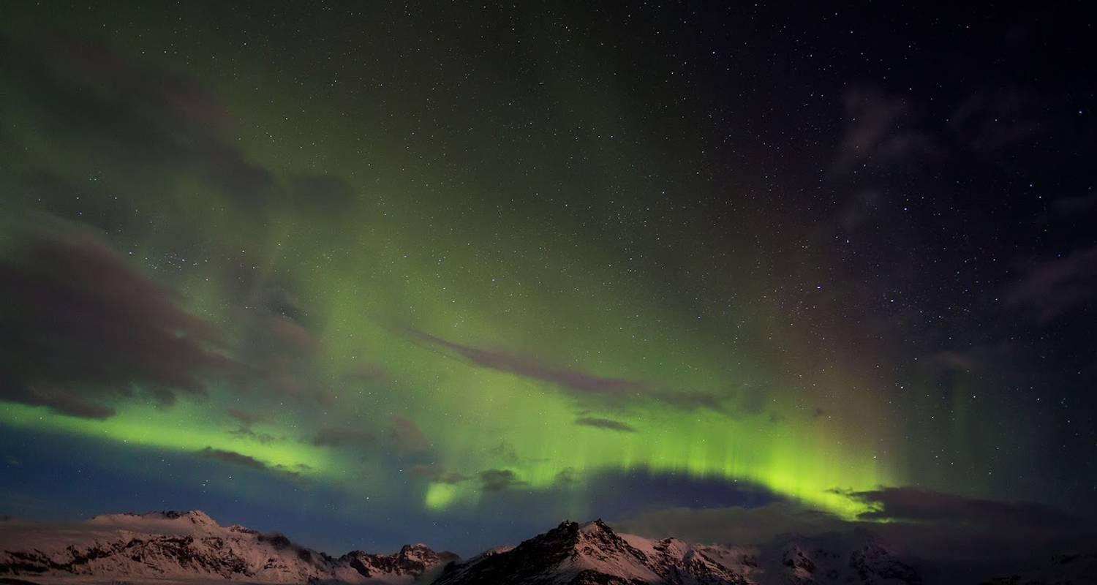

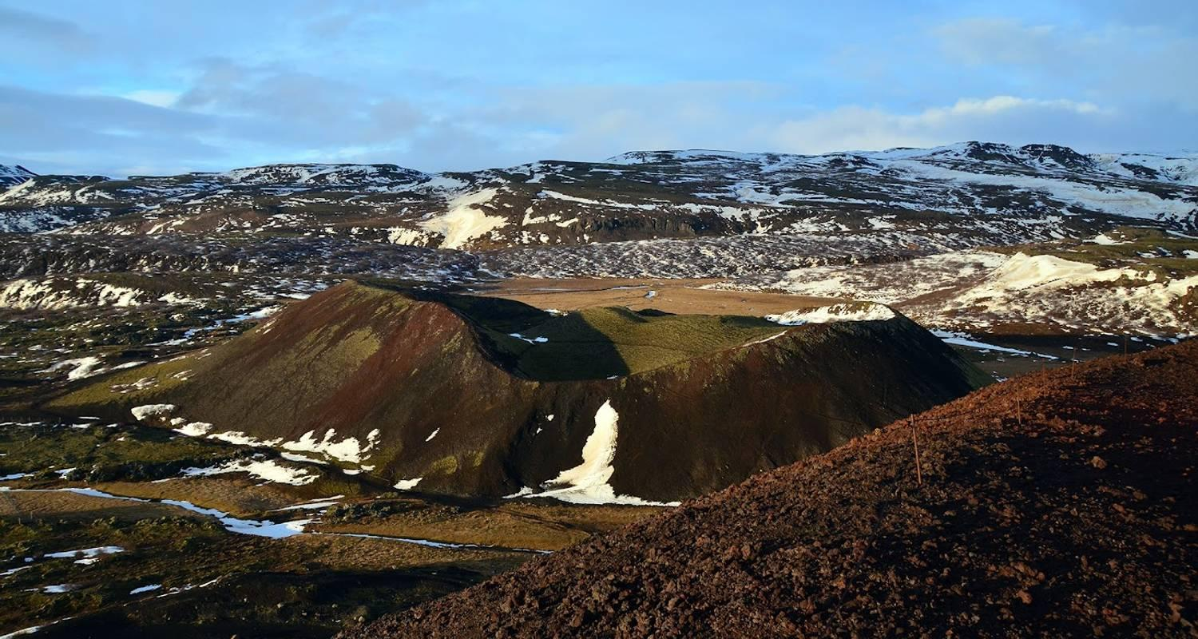

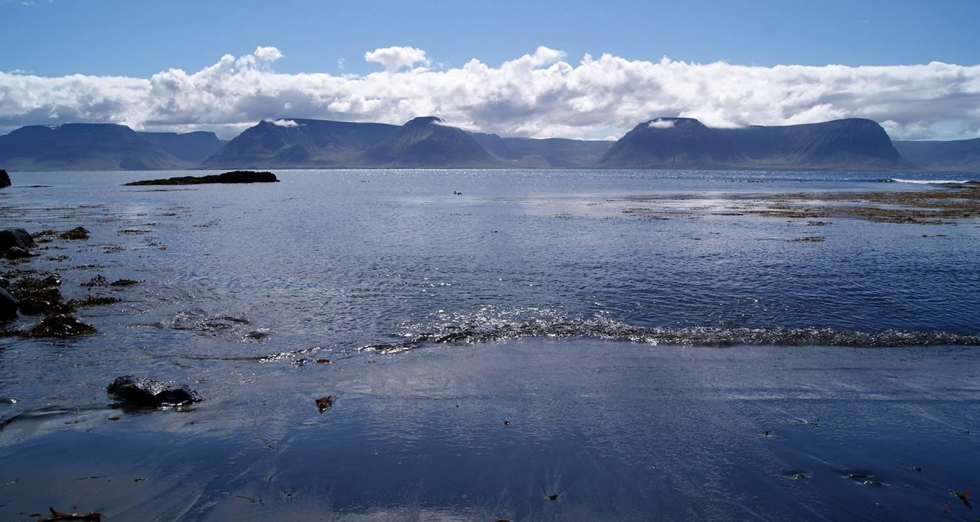

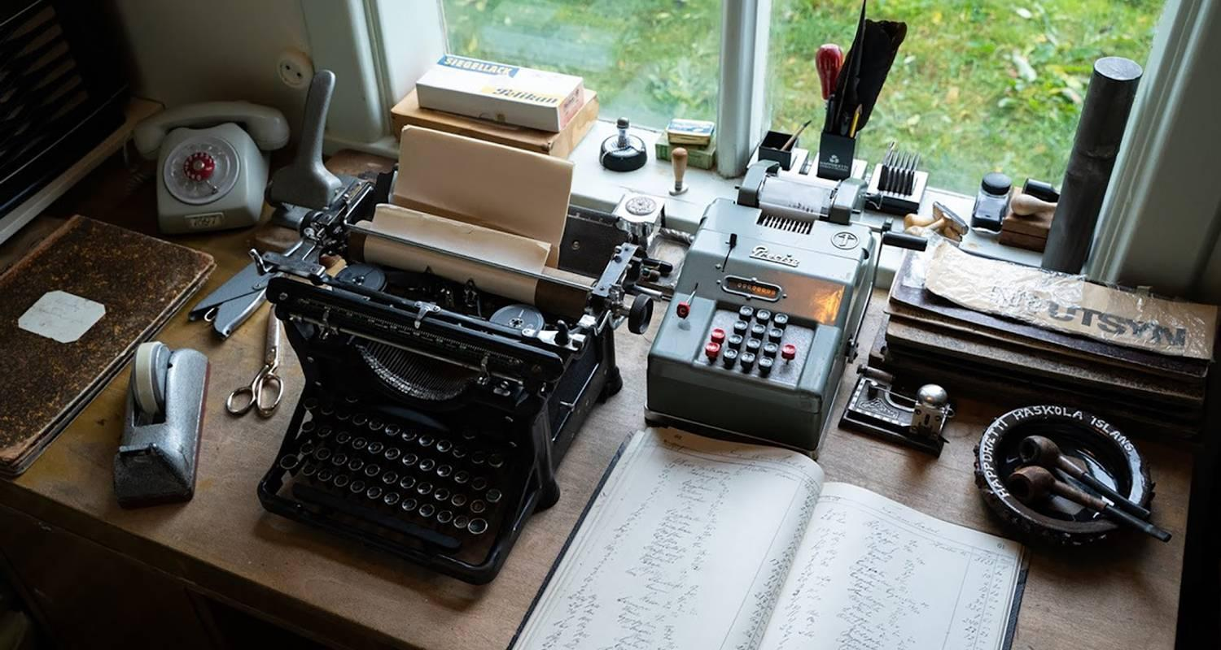



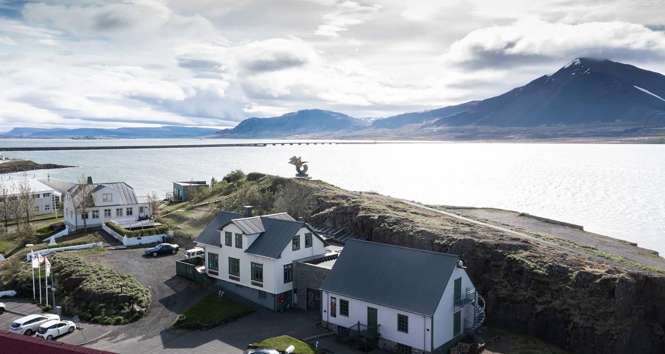

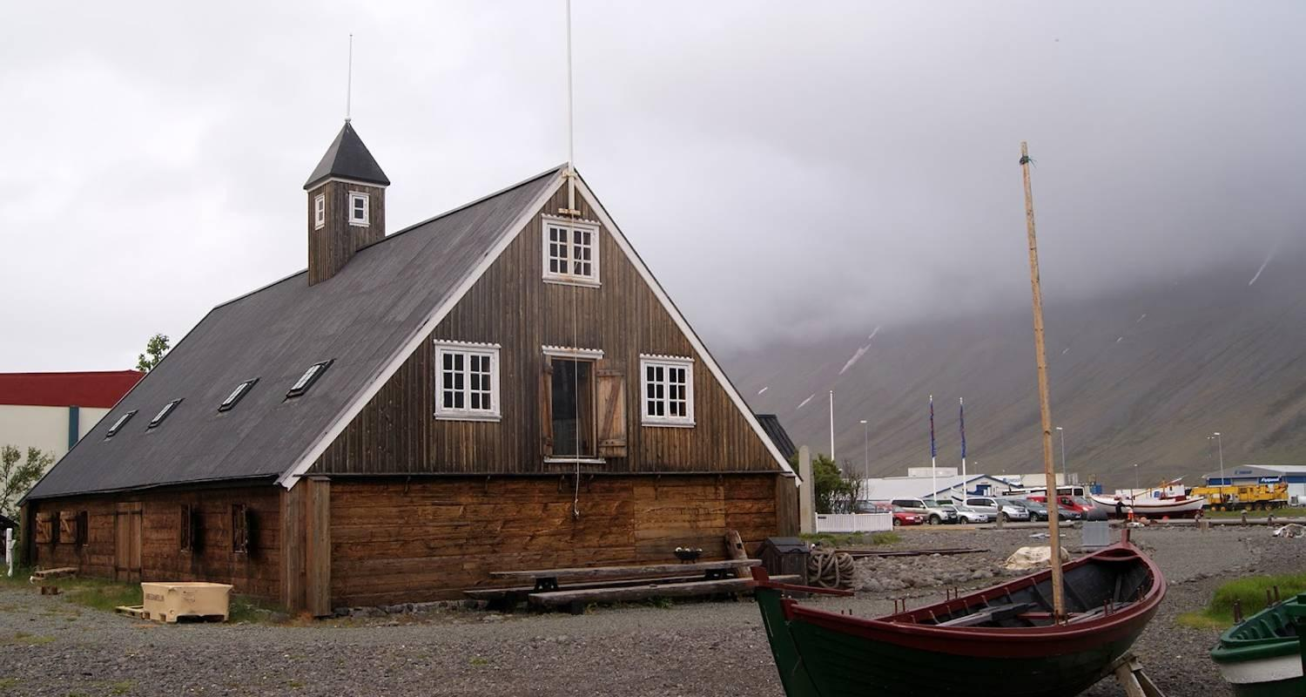

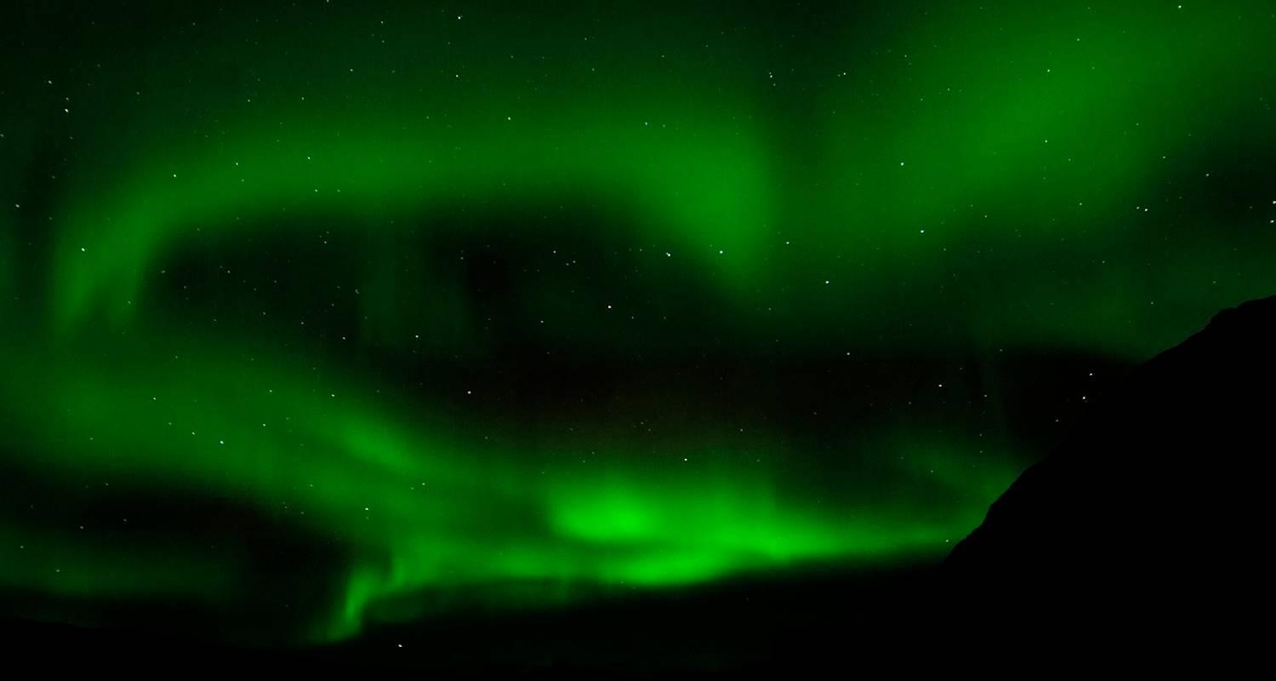

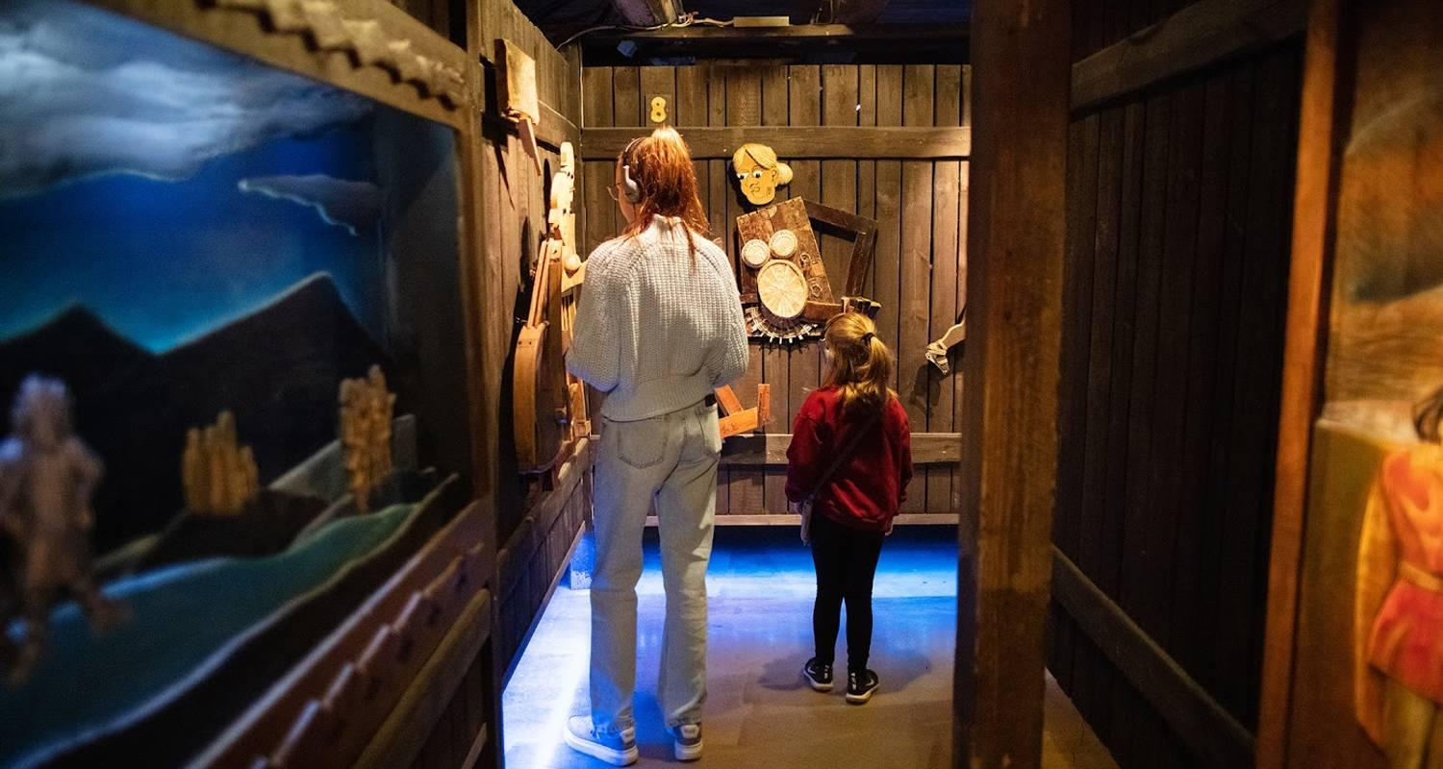

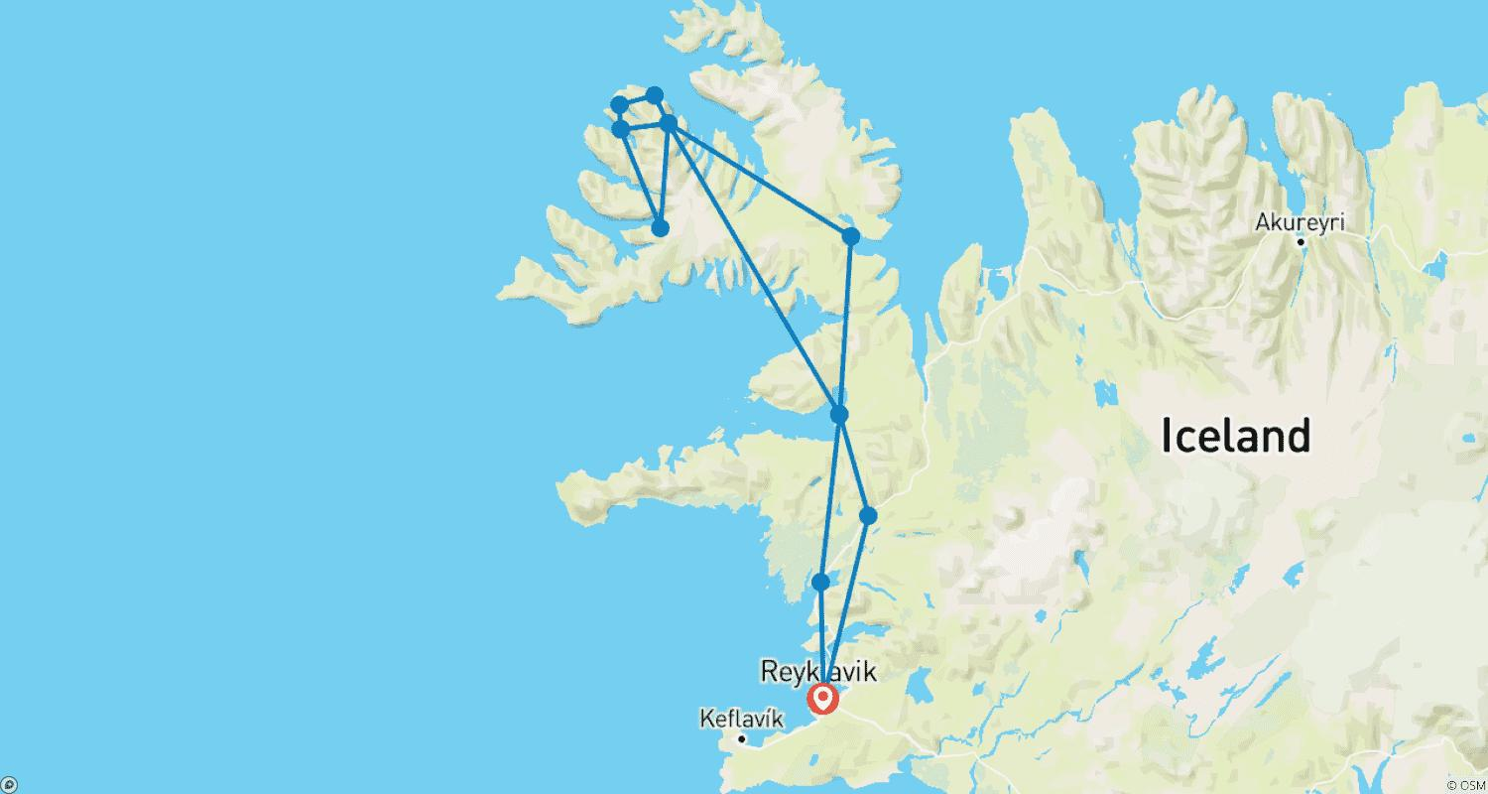

Tour ID: 261613  
Tour Name: East Greenland Northern Lights Photo Tour with Virgil Reglioni Fly & Cruise - 12 Guests Only

Tour destinations: ['Reykjavik', 'Scoresby Sound']

Tour destinations images:

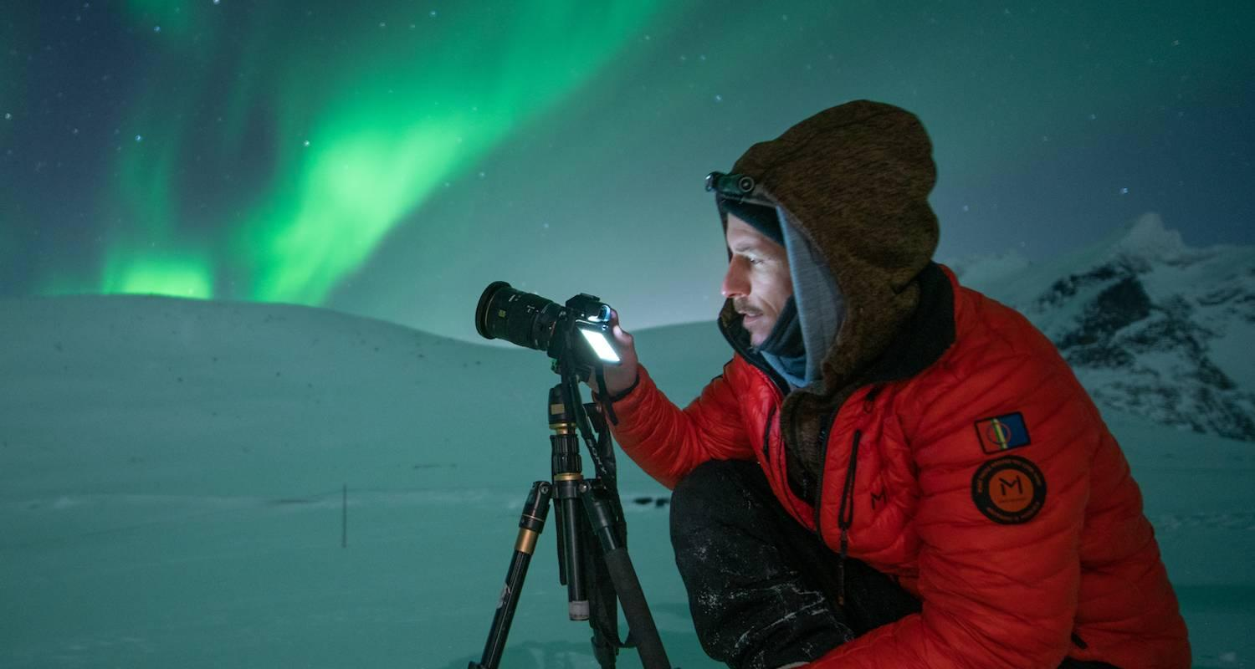

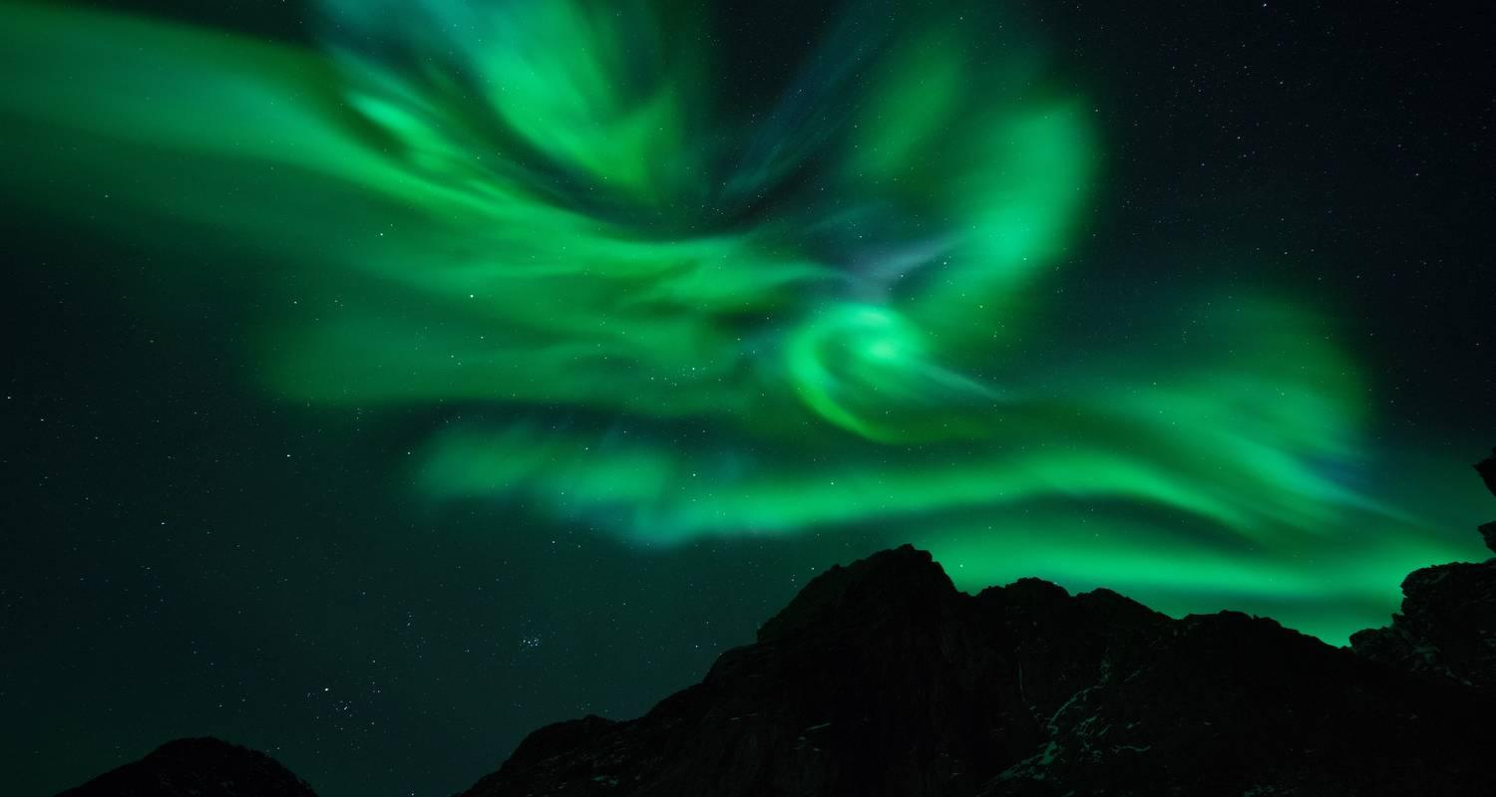

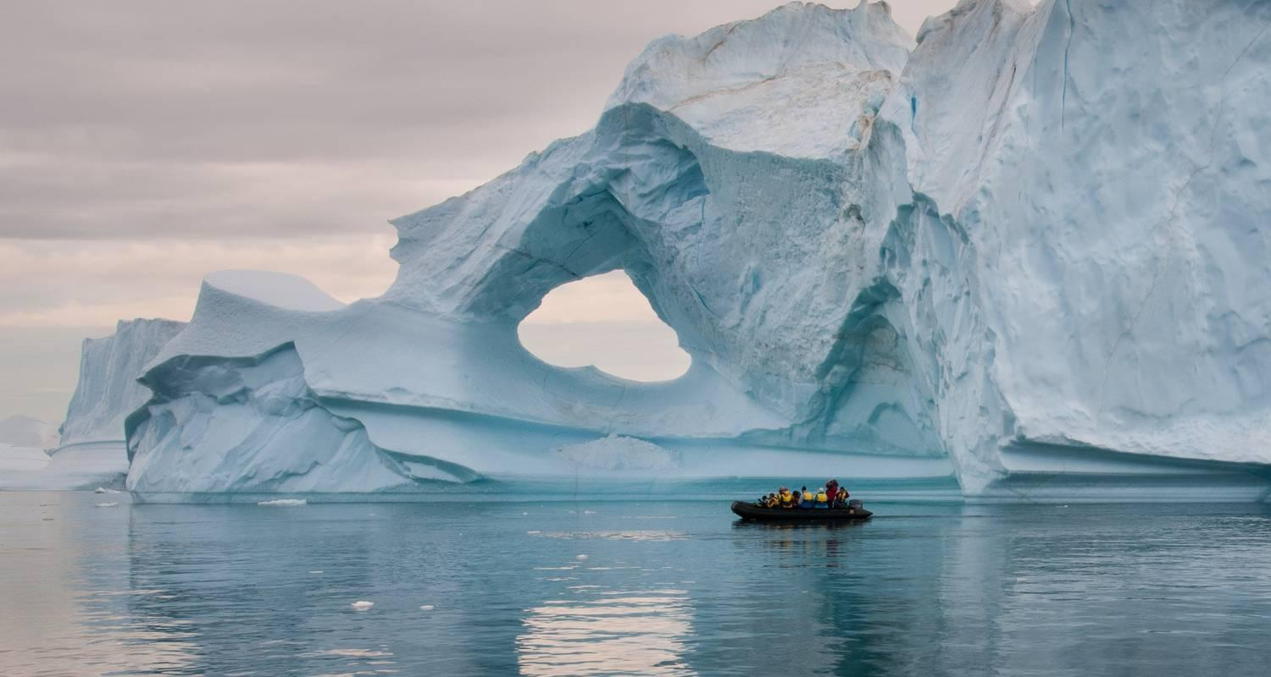

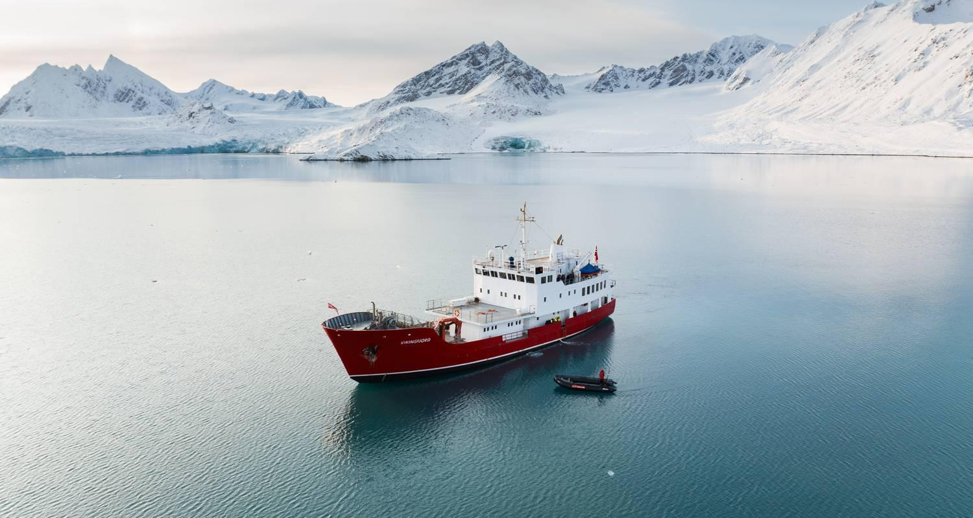

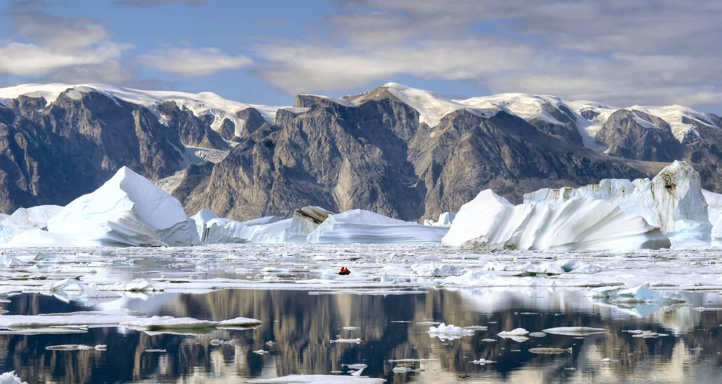

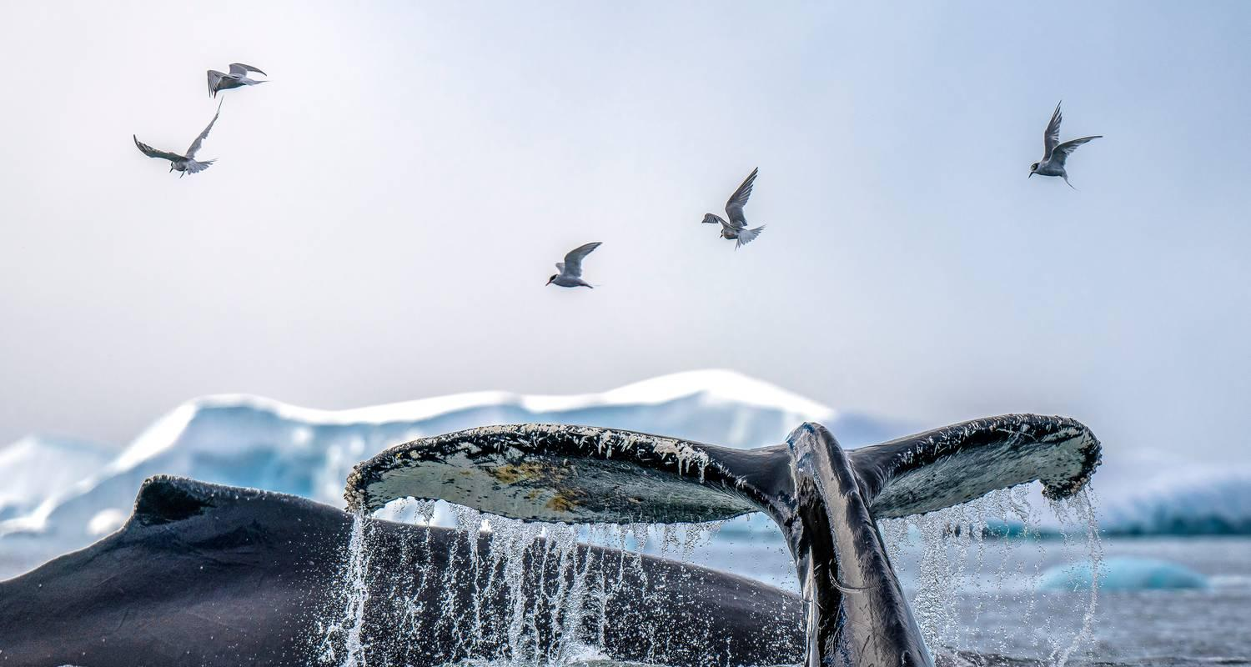

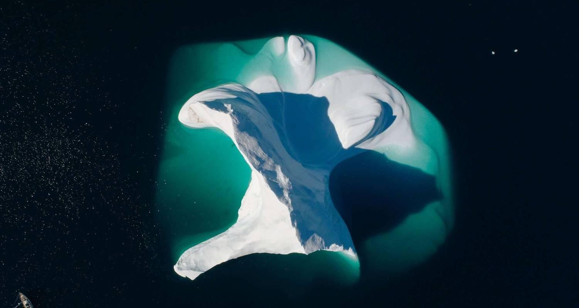

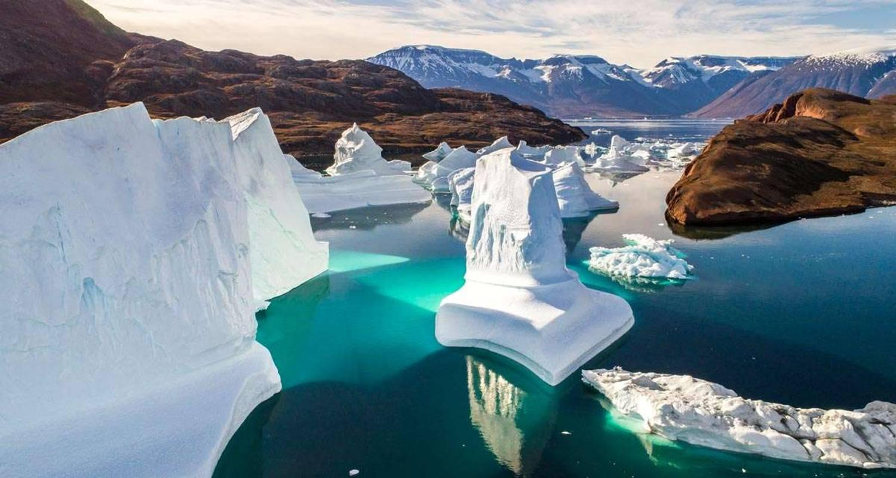

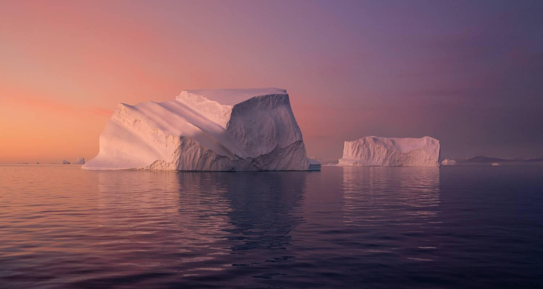

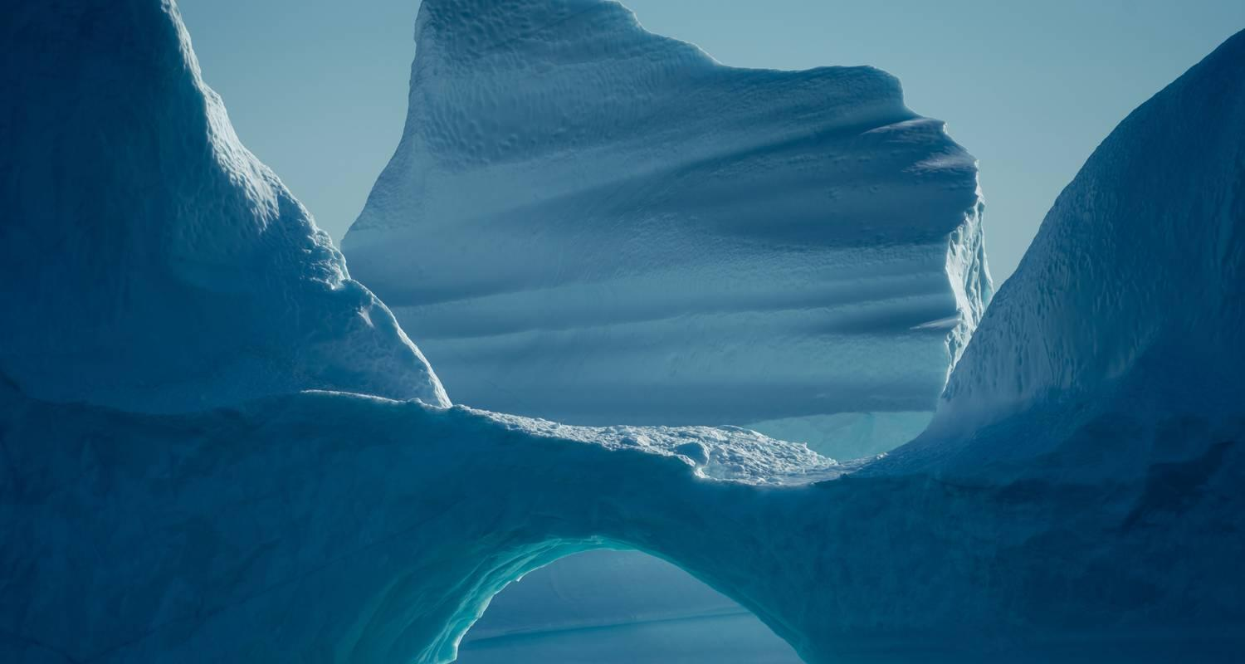

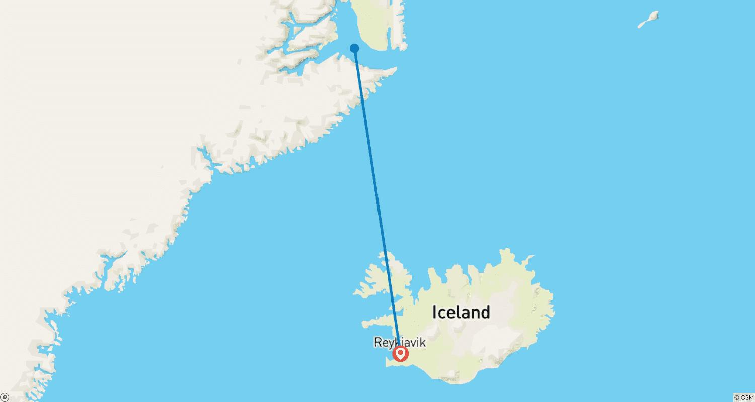

Tour ID: 261842  
Tour Name: Off the Beaten Path in Fjallabak Nature Reserve

Tour destinations: ['Reykjavik', 'Landmannalaugar']

Tour destinations images:

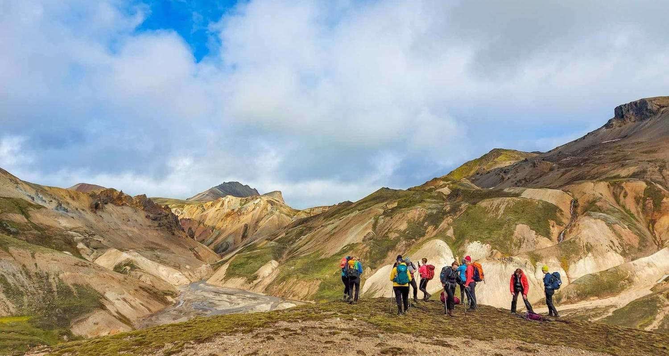

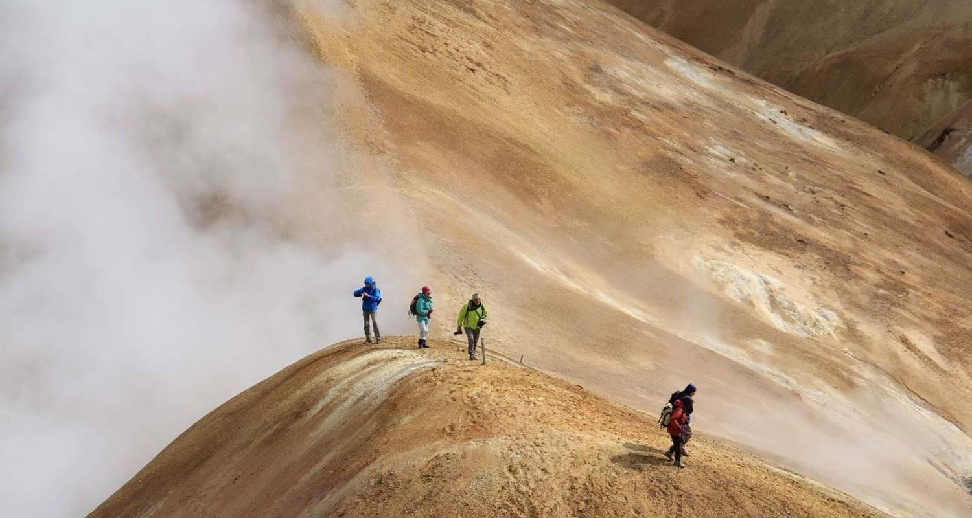

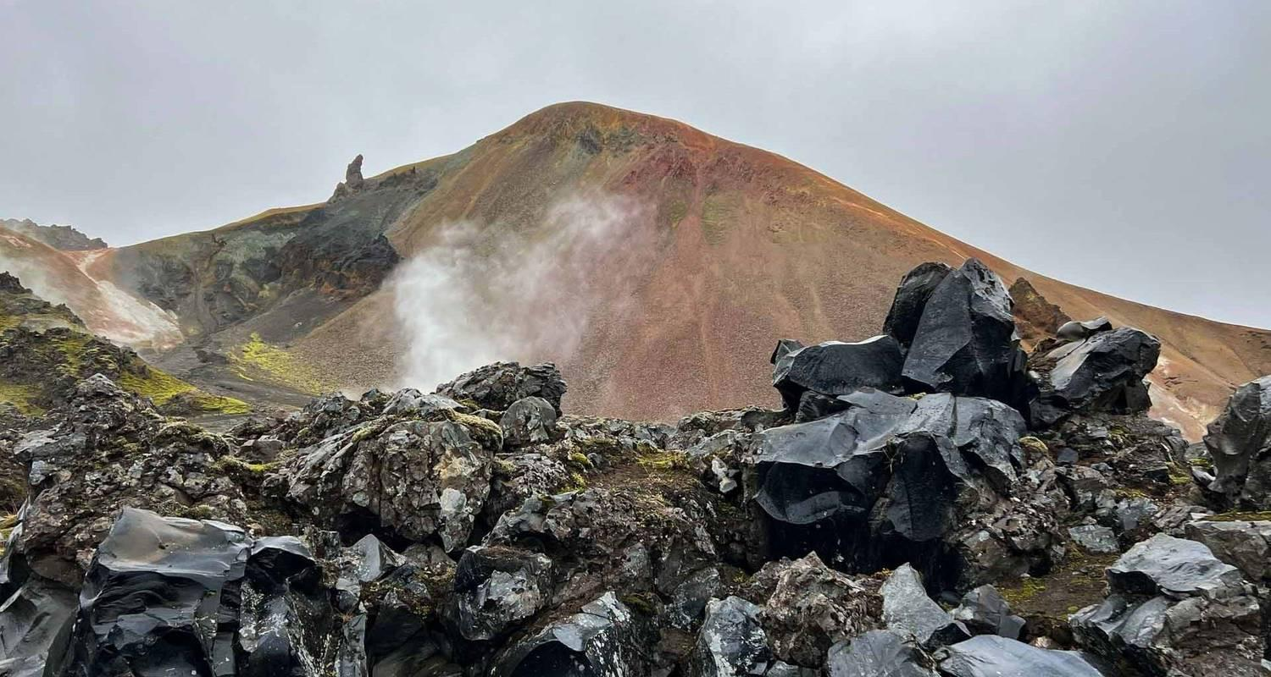

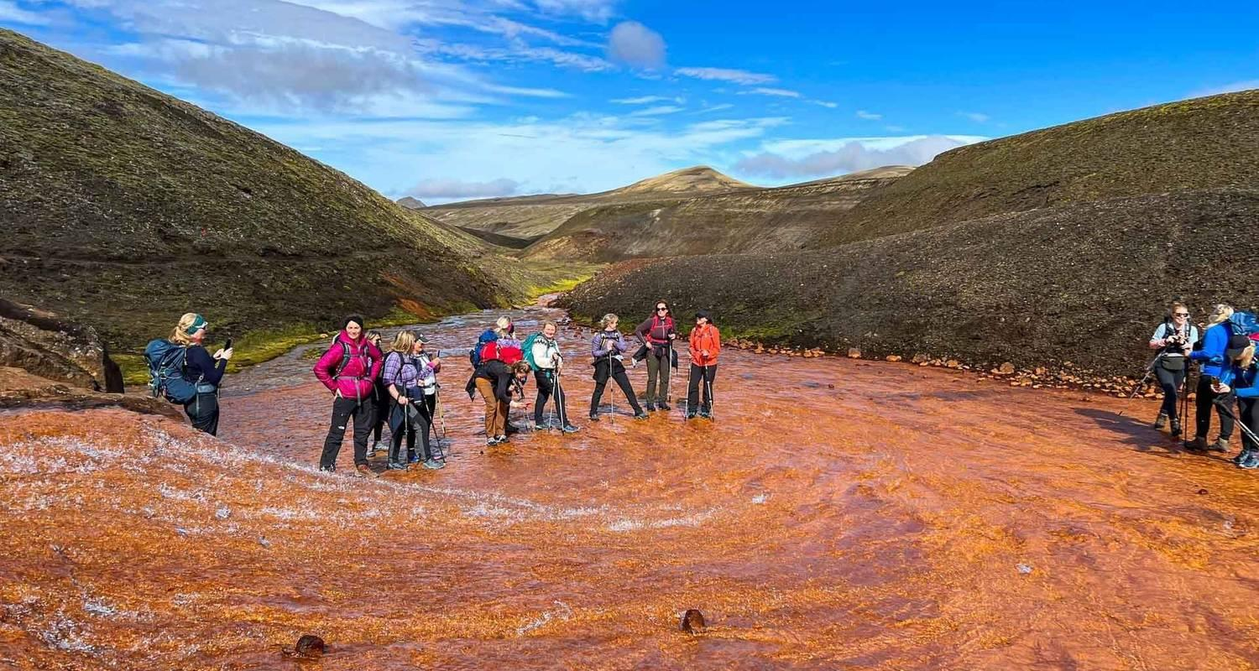

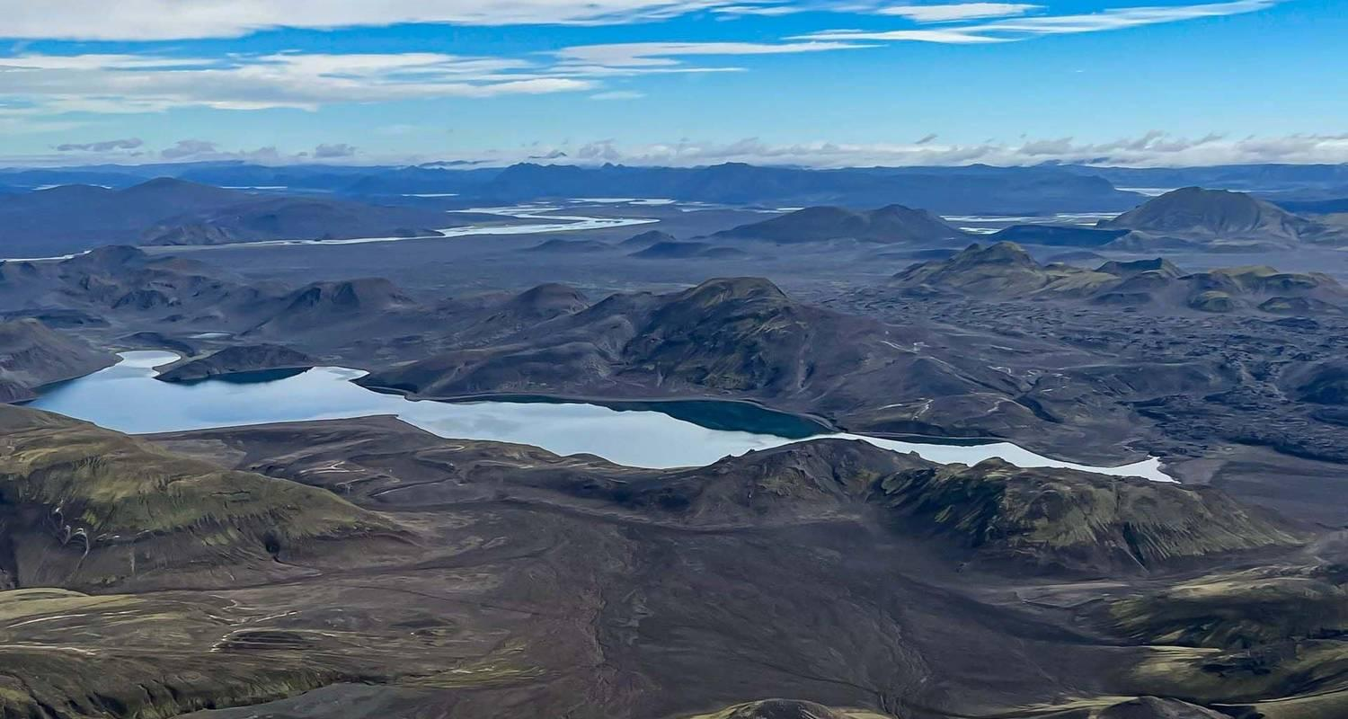

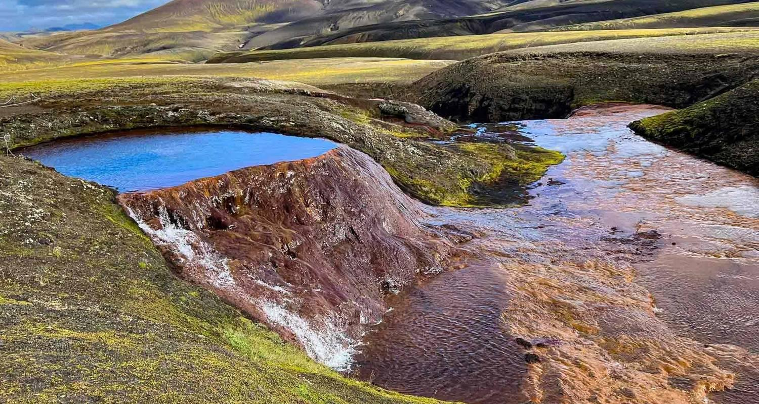

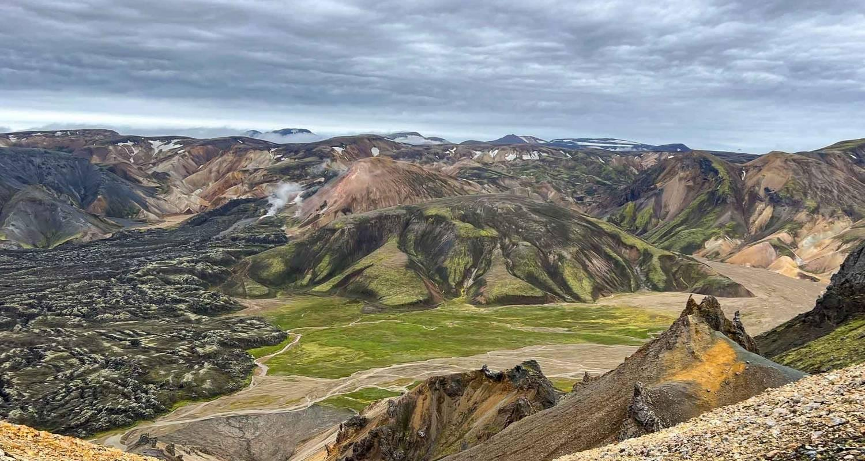

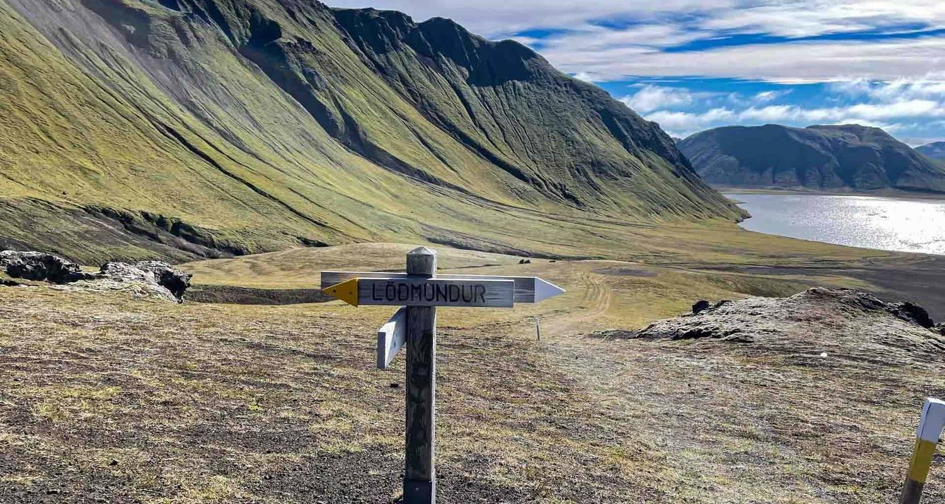

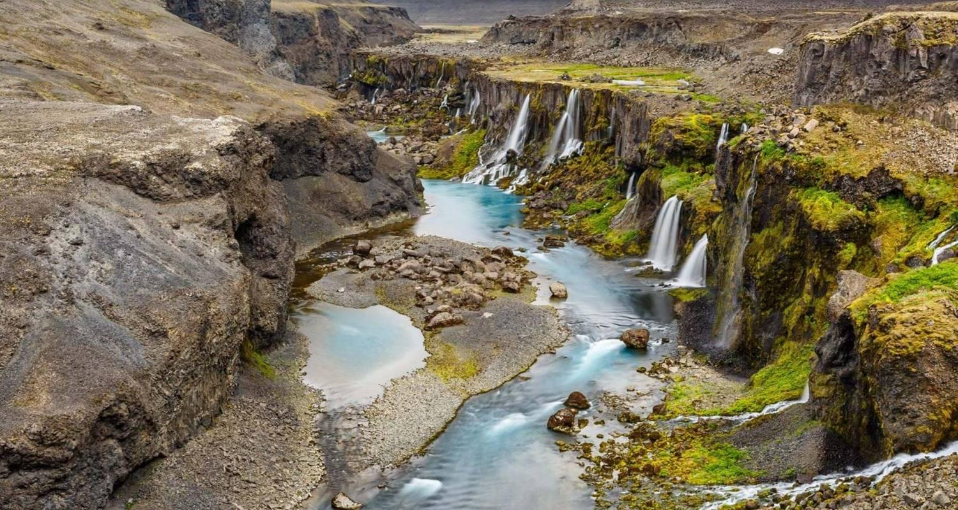

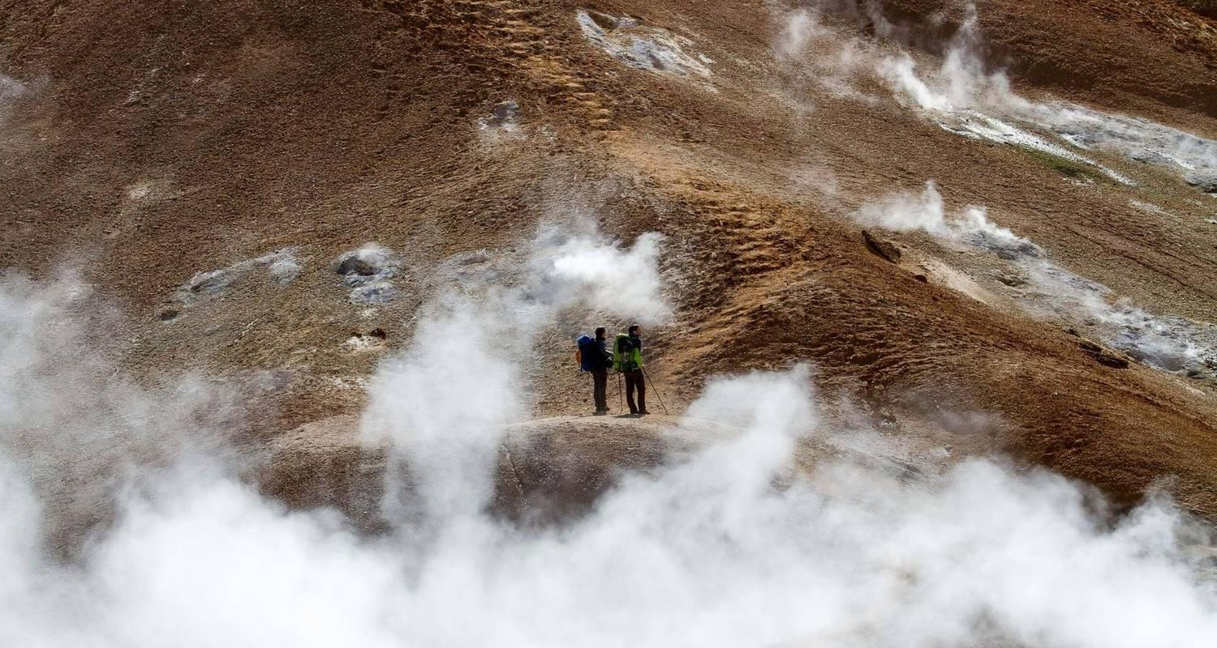

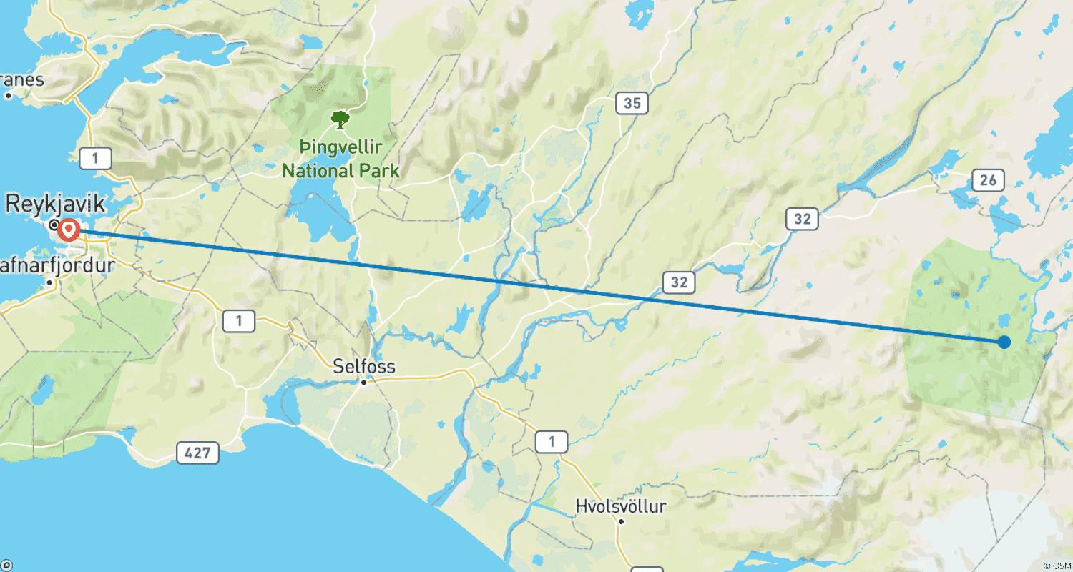

Tour ID: 261924  
Tour Name: Into the Wild: Island Adventure in the Rooftop Tent

Tour destinations: ['Keflavik', 'Reykjavik', 'Thingvellir National Park', 'Haukadalur', 'Gullfoss', 'Skogafoss', 'Reynisfjara', 'Vik', 'Skaftafell', 'Svartifoss', 'Hofn', 'Dettifoss', 'Myvatn', 'Godafoss', 'Akureyri']

Tour destinations images:

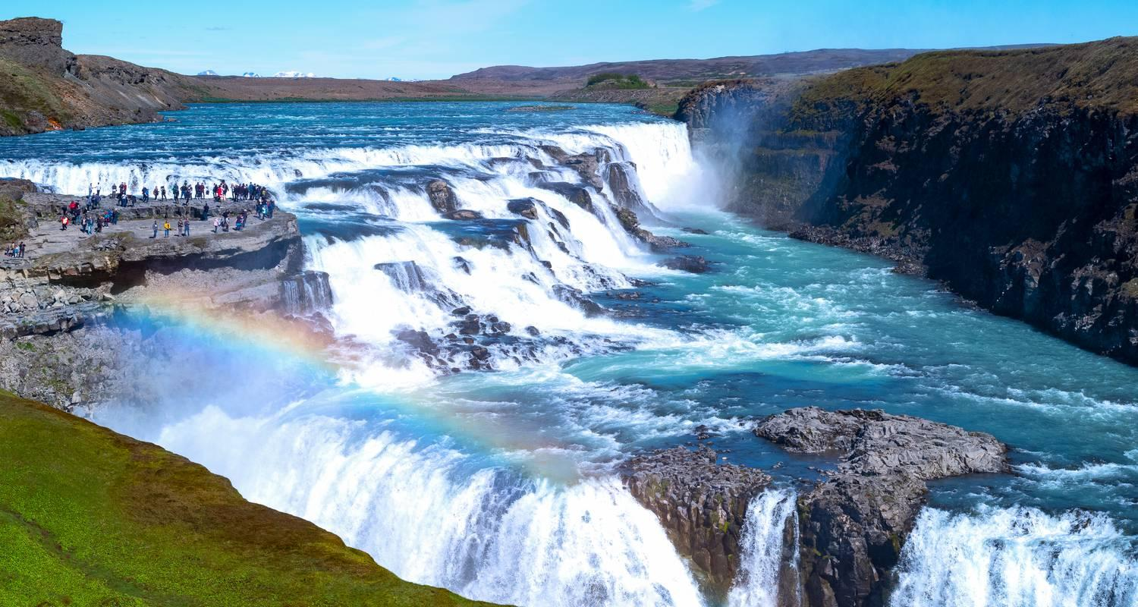

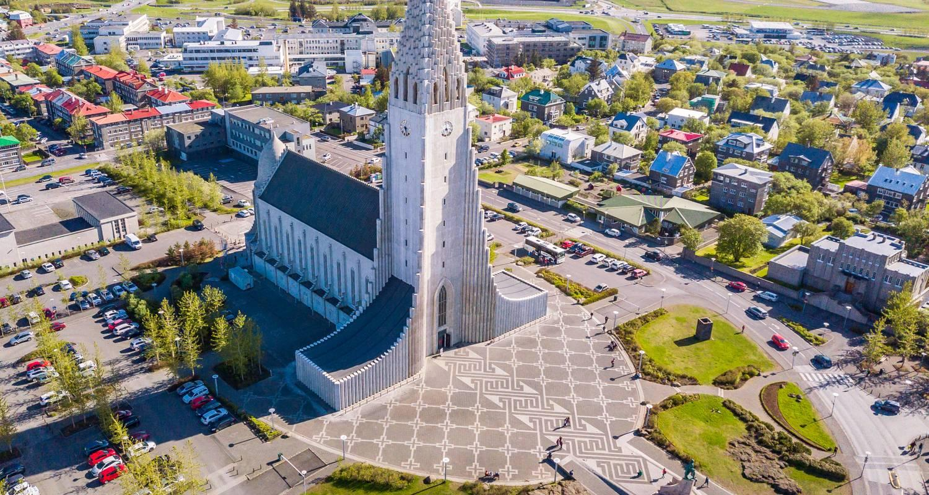

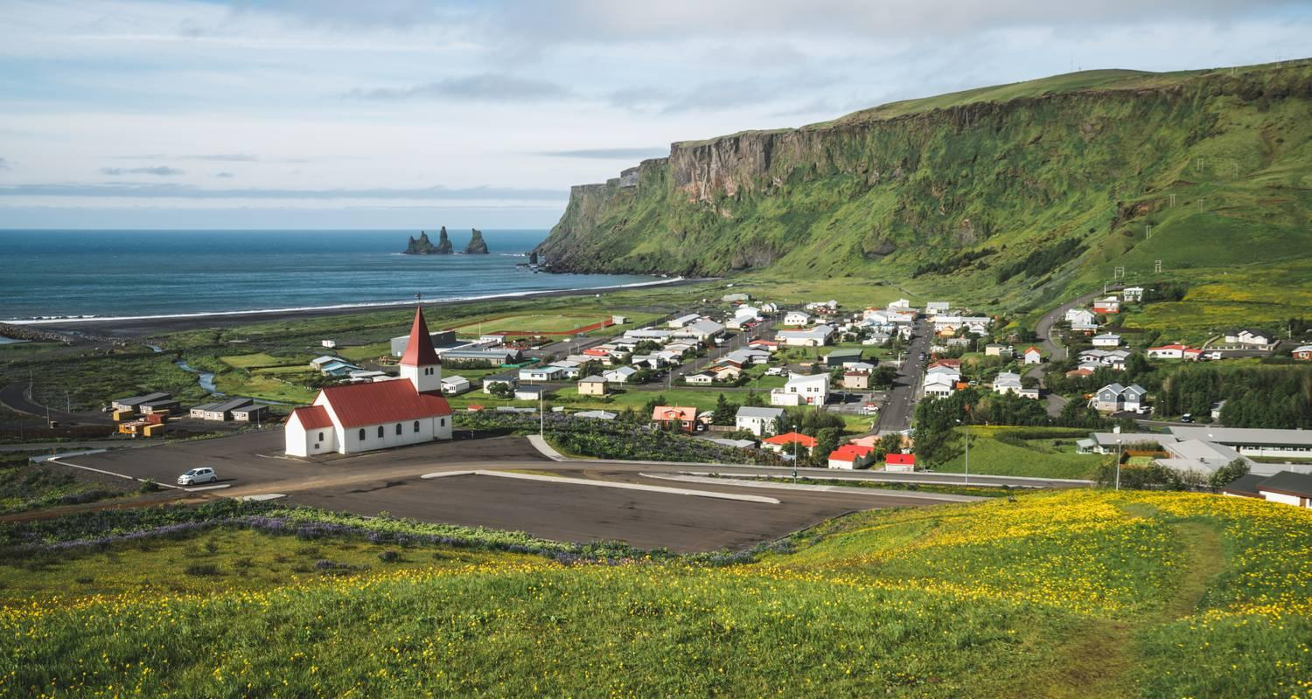

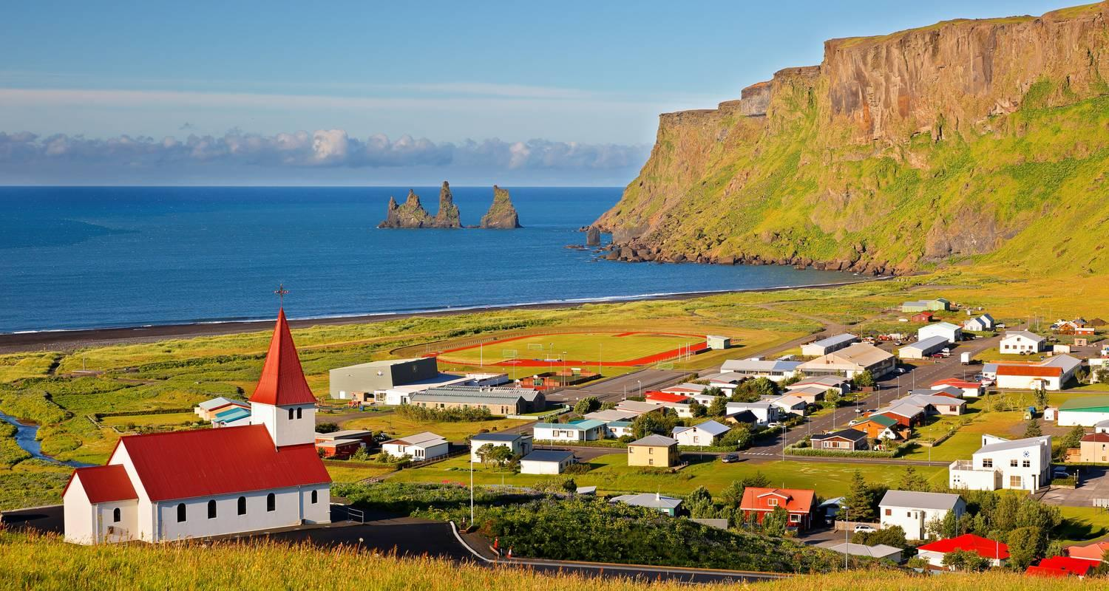

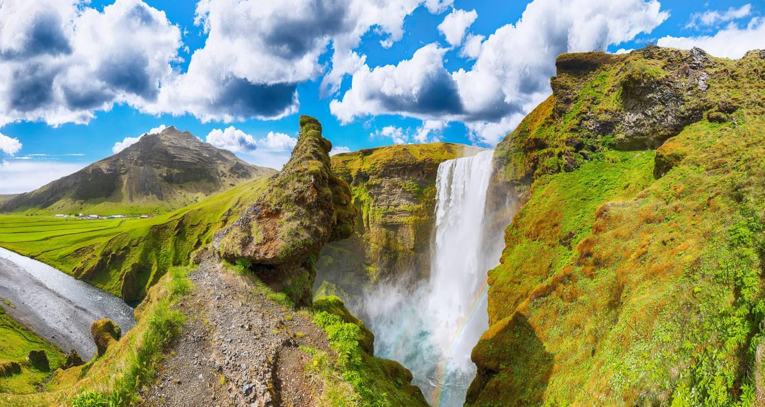

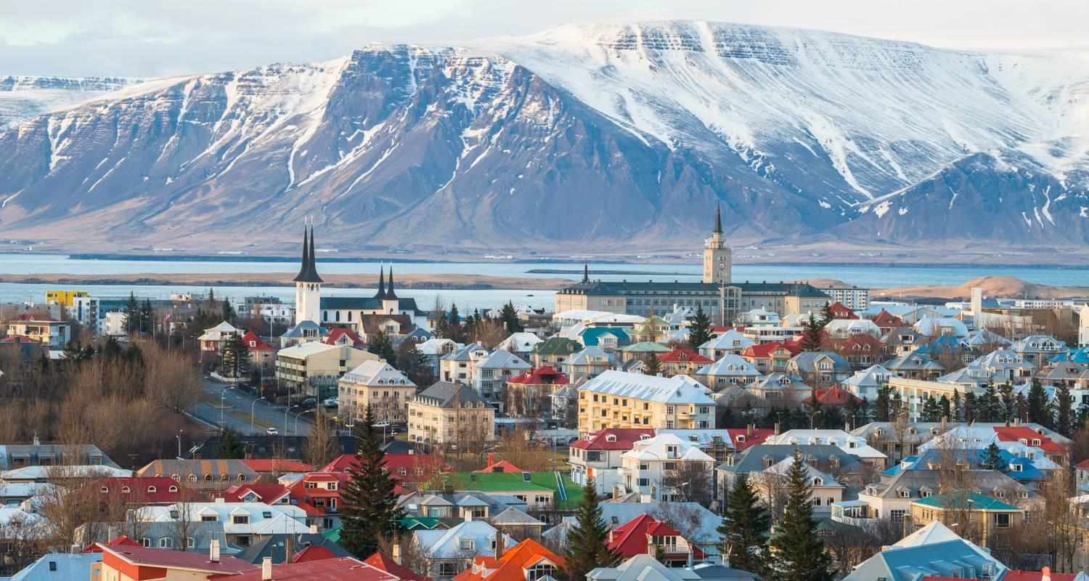

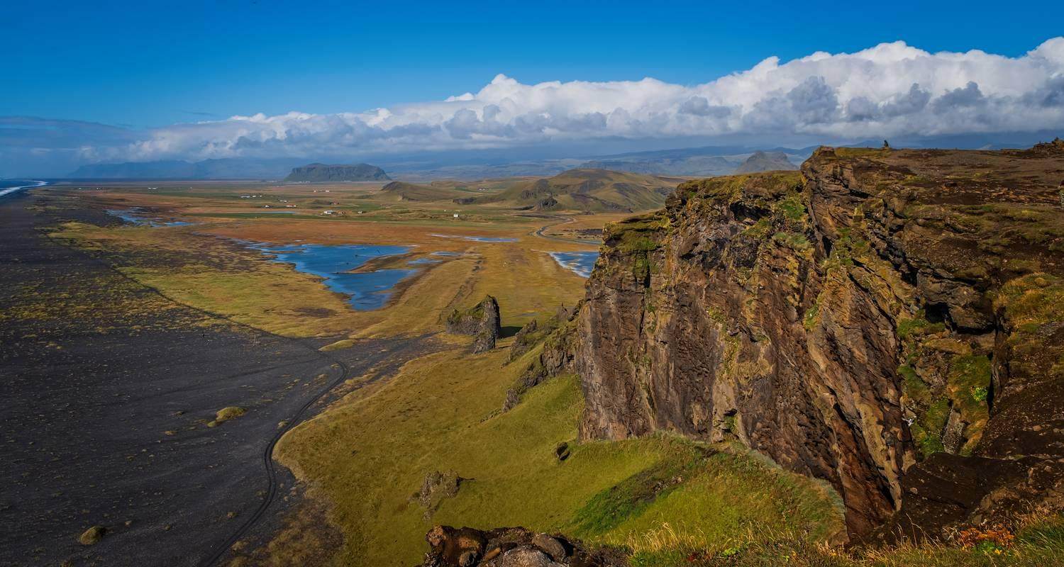

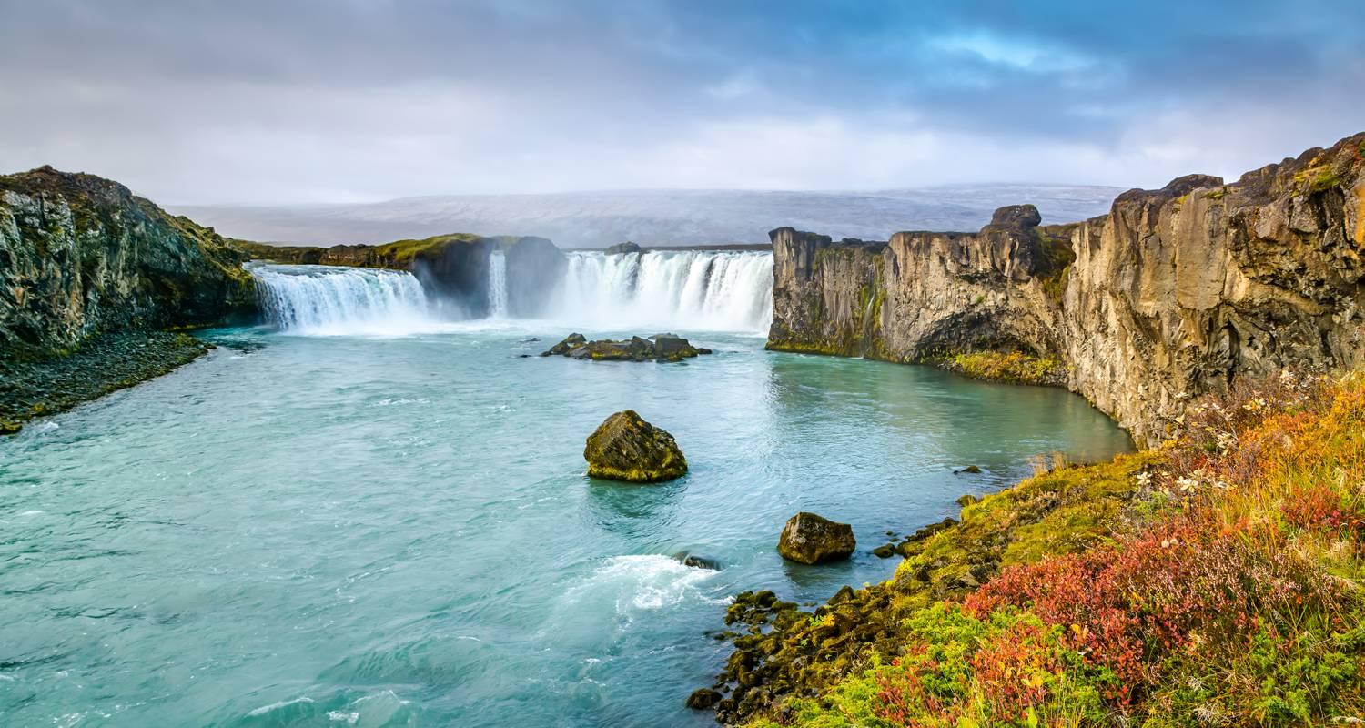

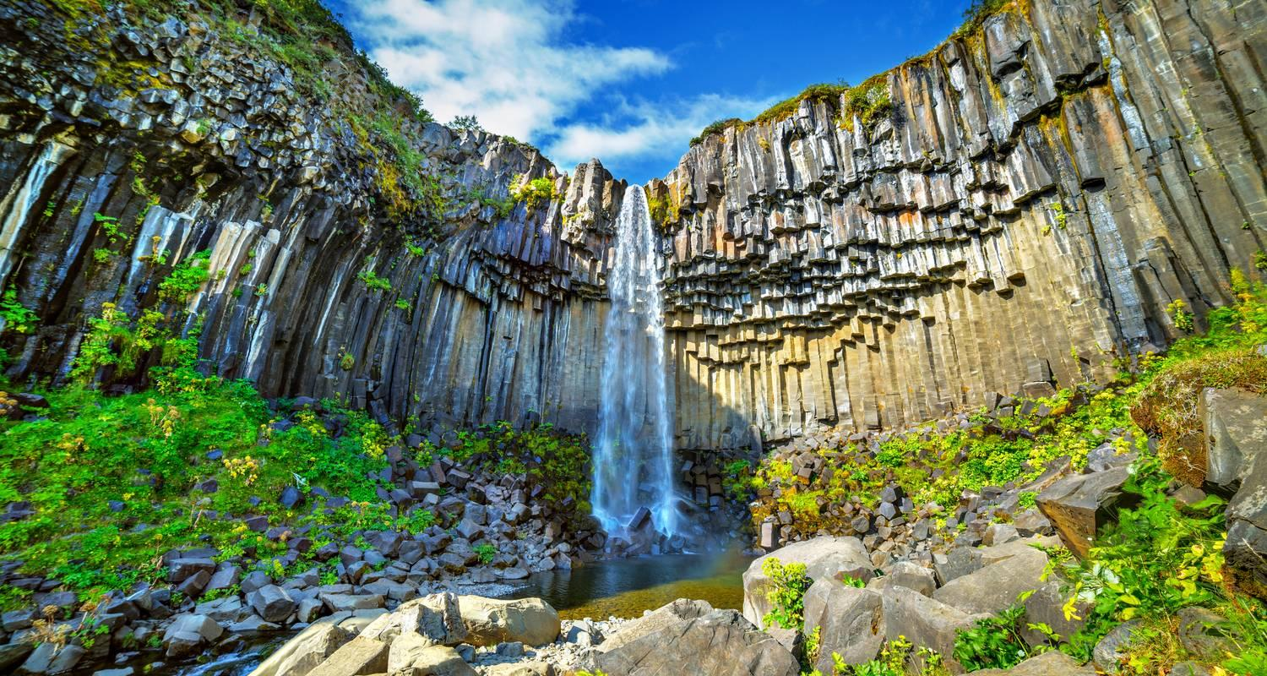

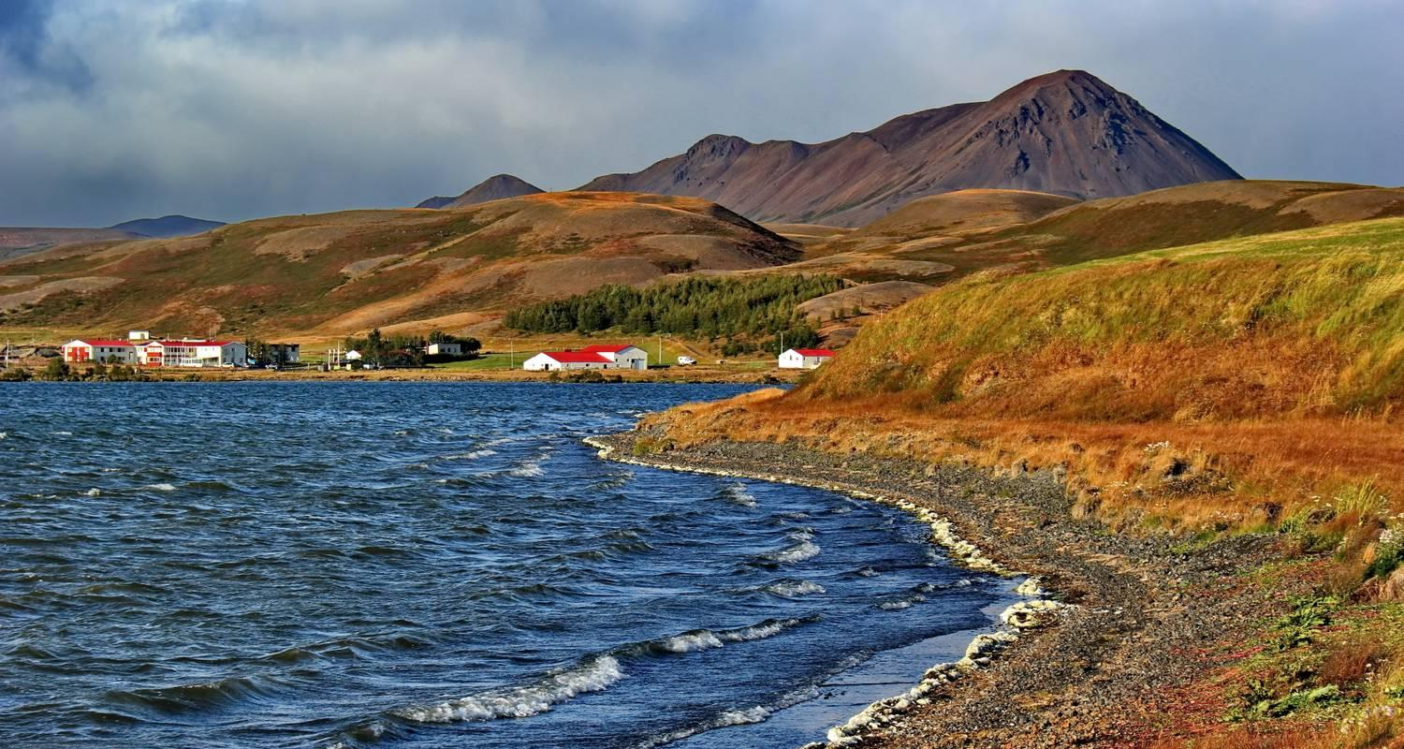

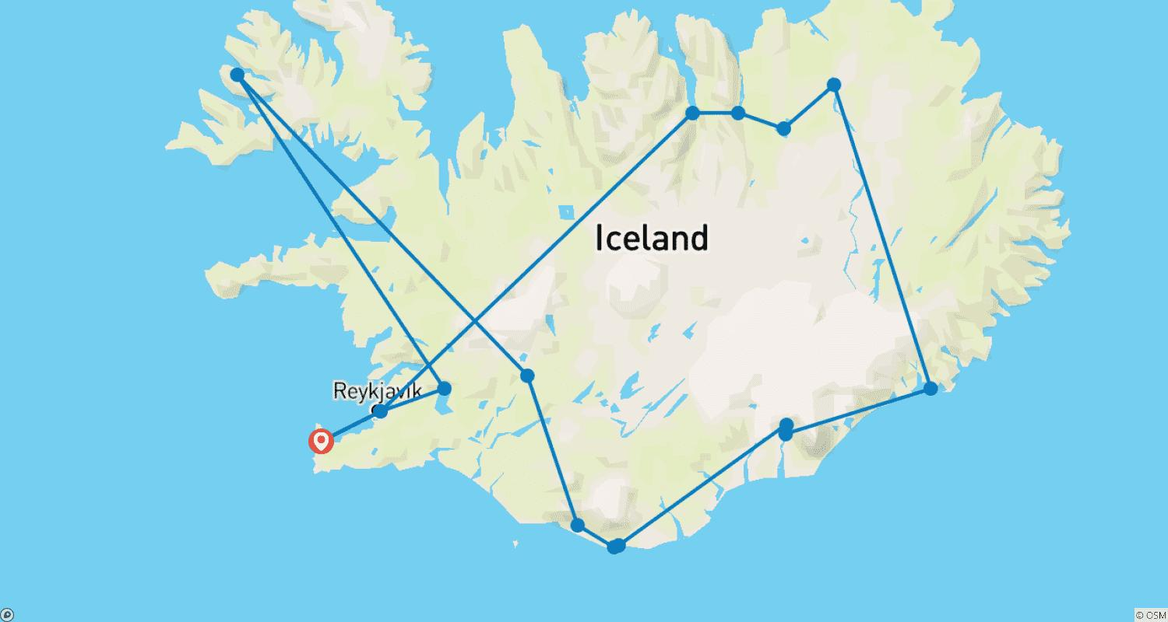

Tour ID: 262145  
Tour Name: Northwest Passage—Across the Top of the World (Alaska to Greenland)

Tour destinations: ['Seattle', 'Nome', 'Herschel Island', 'Ulukhaktok', 'Cambridge Bay', 'Gjoa Haven', 'Lancaster Sound', 'Disko Bay', 'Ilulissat', 'Sisimiut', 'Evighedsfjorden', 'Nuuk', 'Reykjavik']

Tour destinations images:

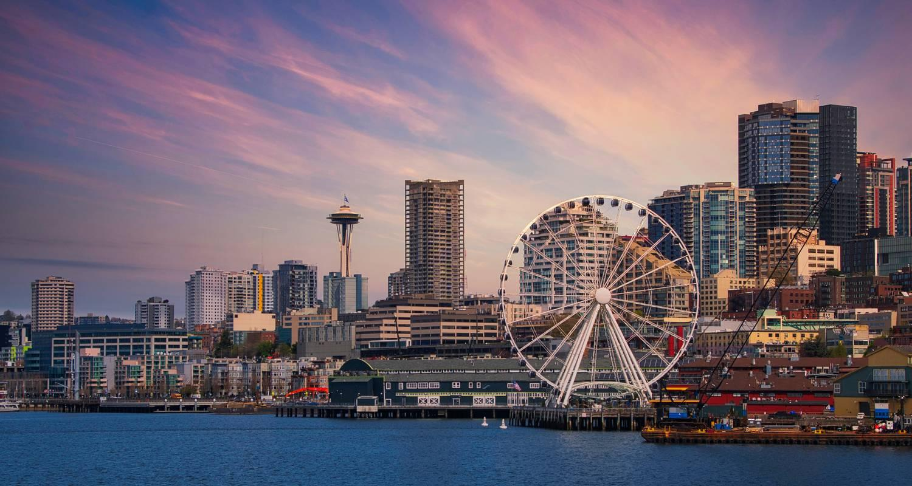

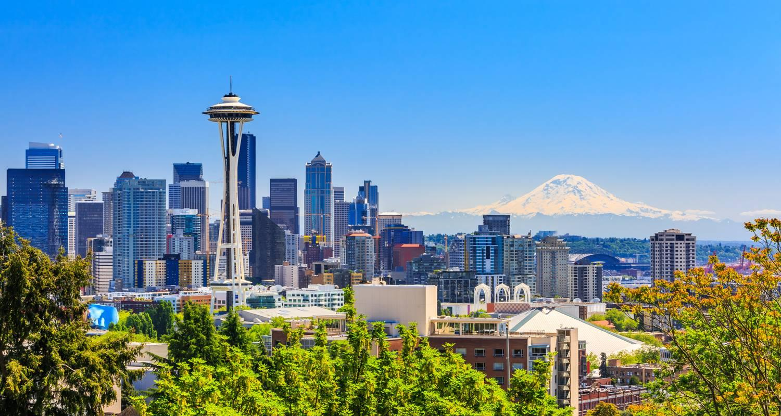

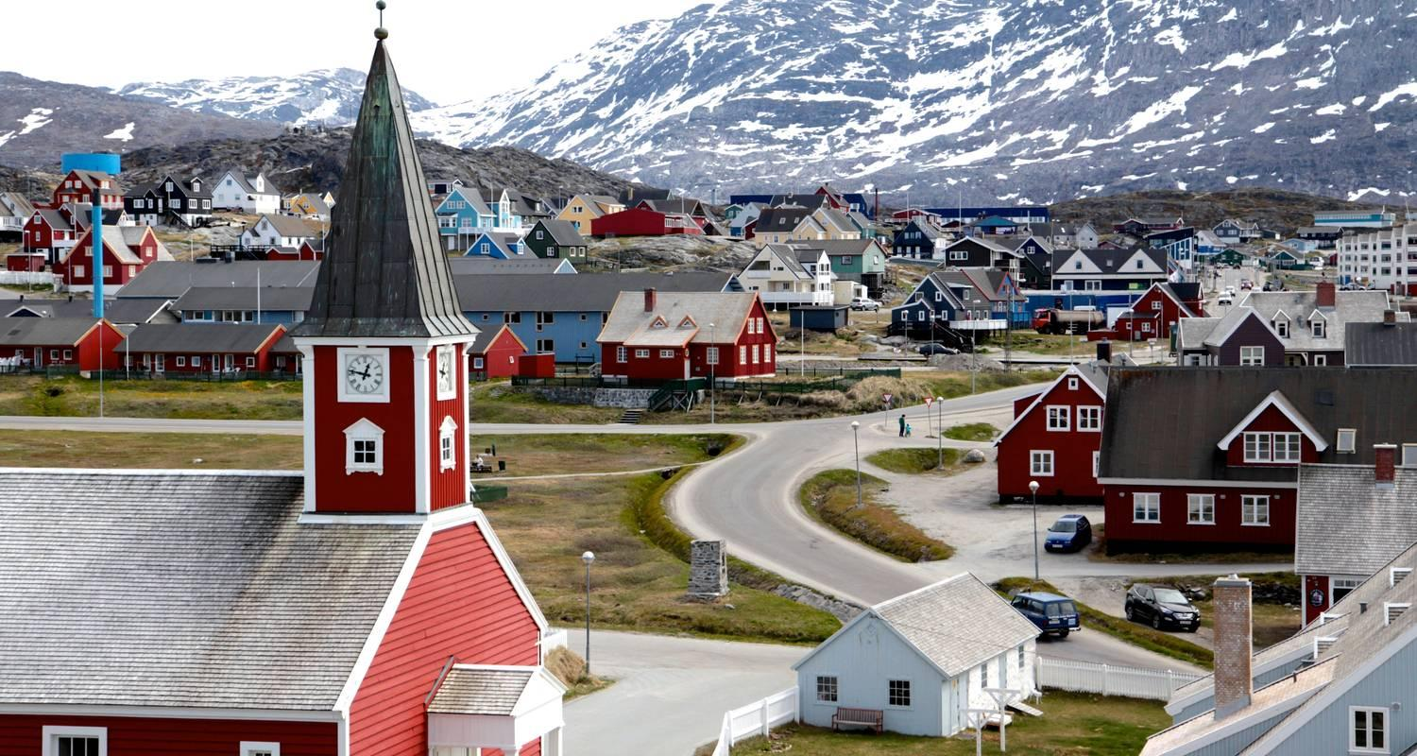

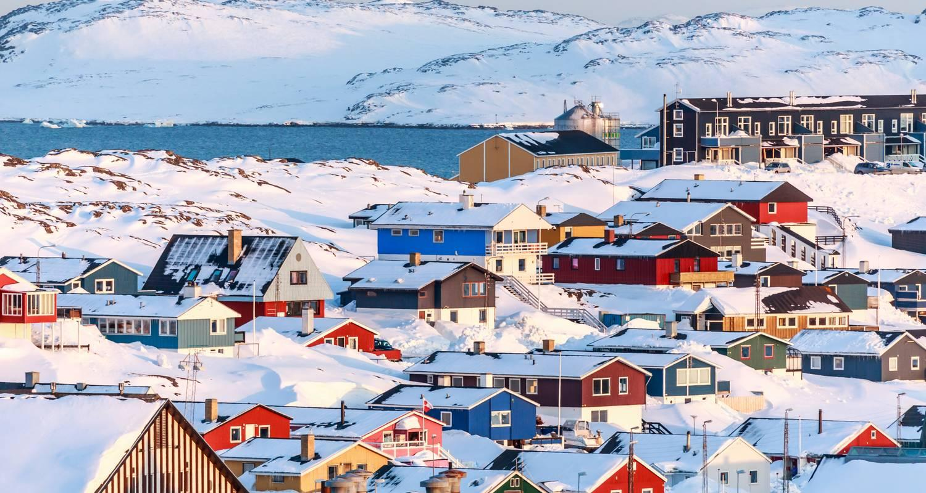





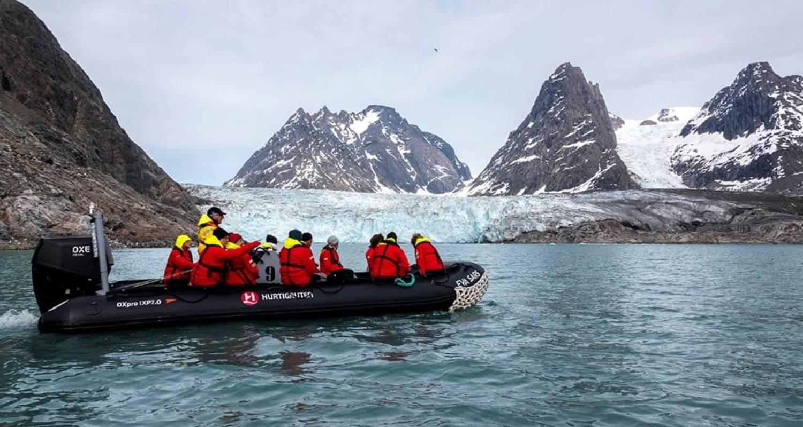

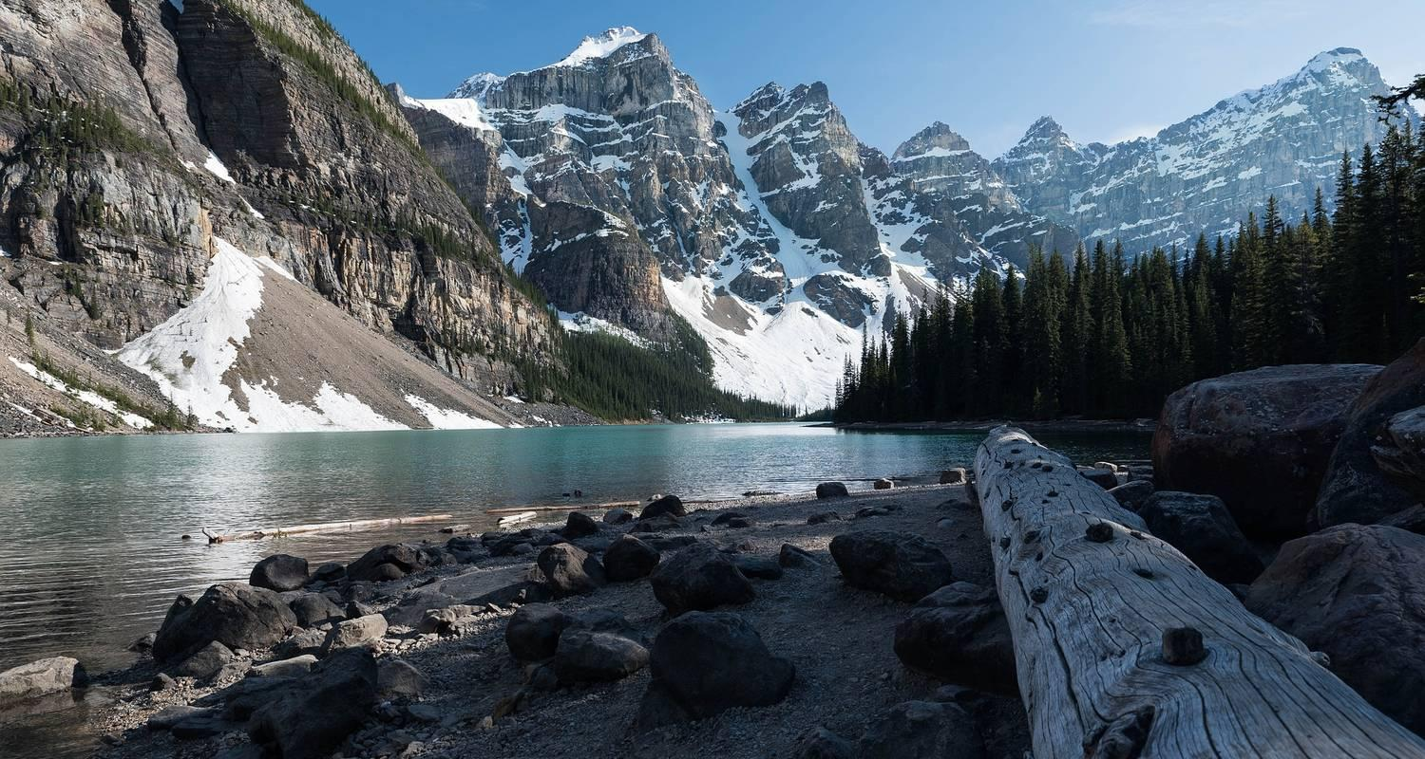

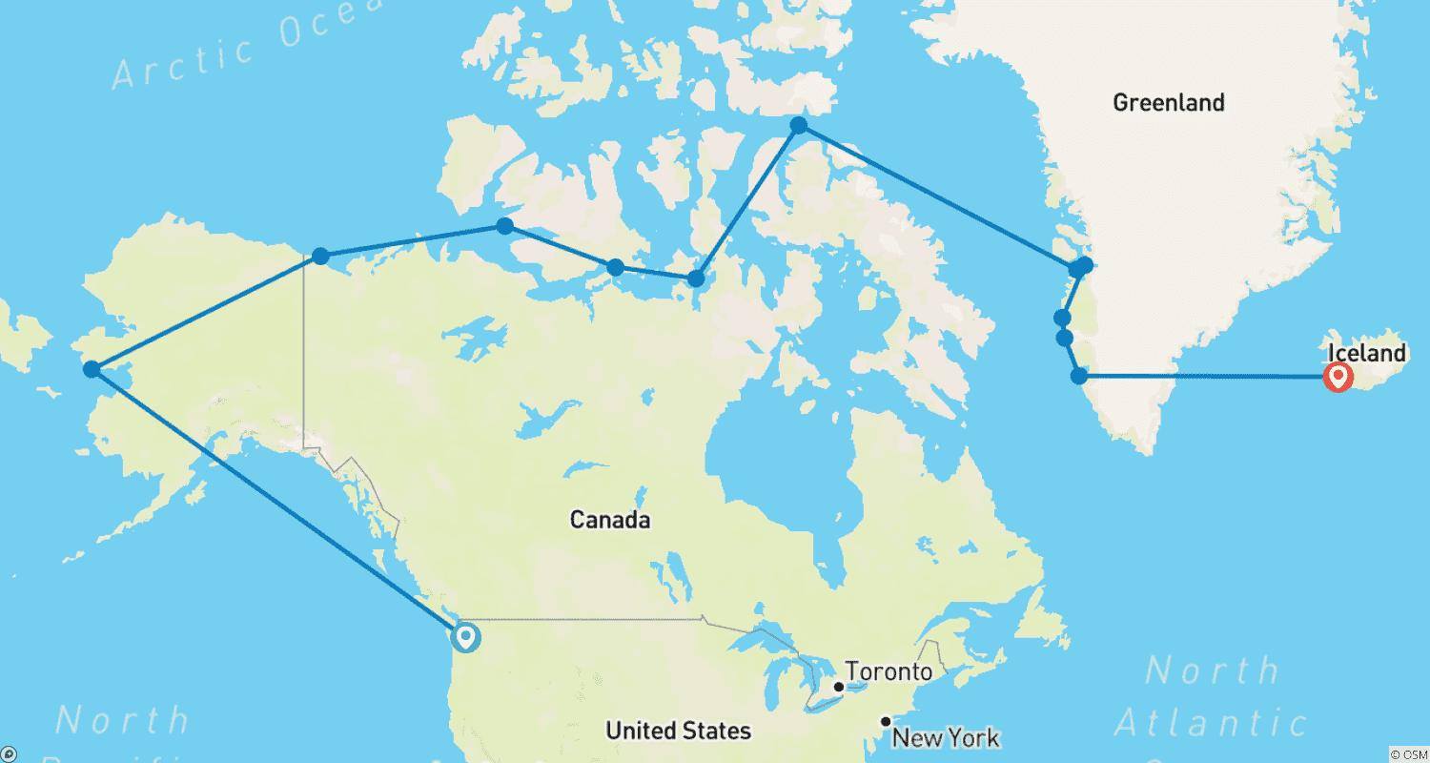

Tour ID: 262540  
Tour Name: Northwest Passage—Through the Arctic Labyrinth (Greenland to Alaska)

Tour destinations: ['Reykjavik', 'Nuuk', 'Evighedsfjorden', 'Sisimiut', 'Ilulissat', 'Lancaster Sound', 'Gjoa Haven', 'Cambridge Bay', 'Ulukhaktok', 'Herschel Island', 'Nome', 'Seattle']

Tour destinations images:



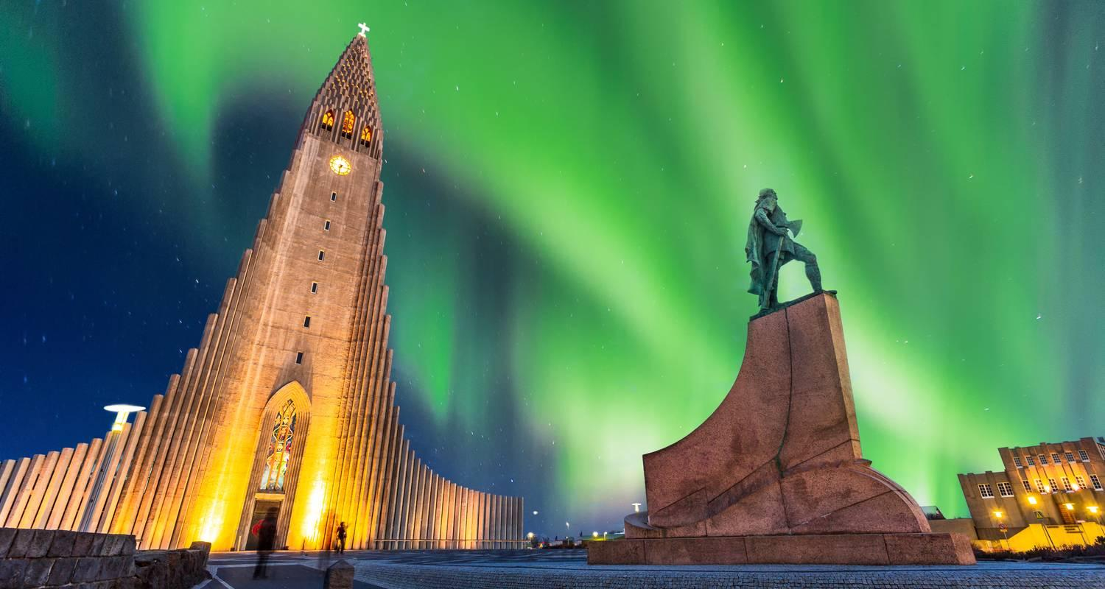

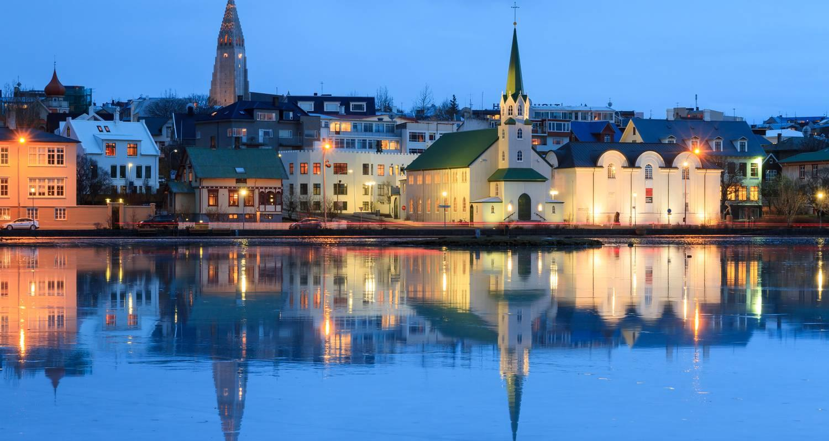





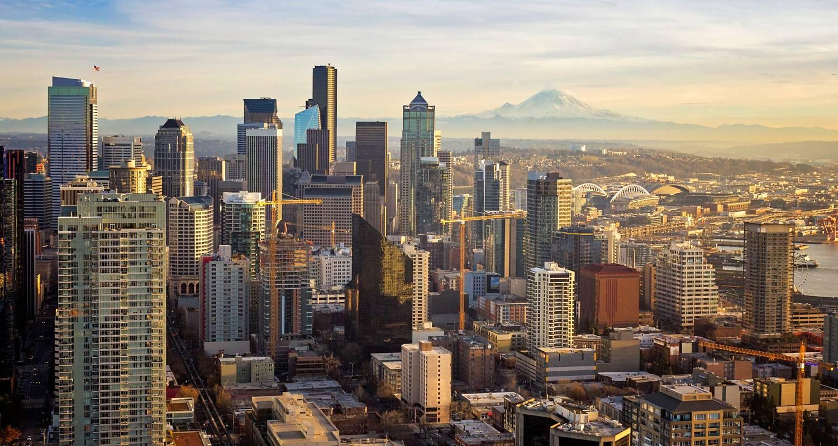



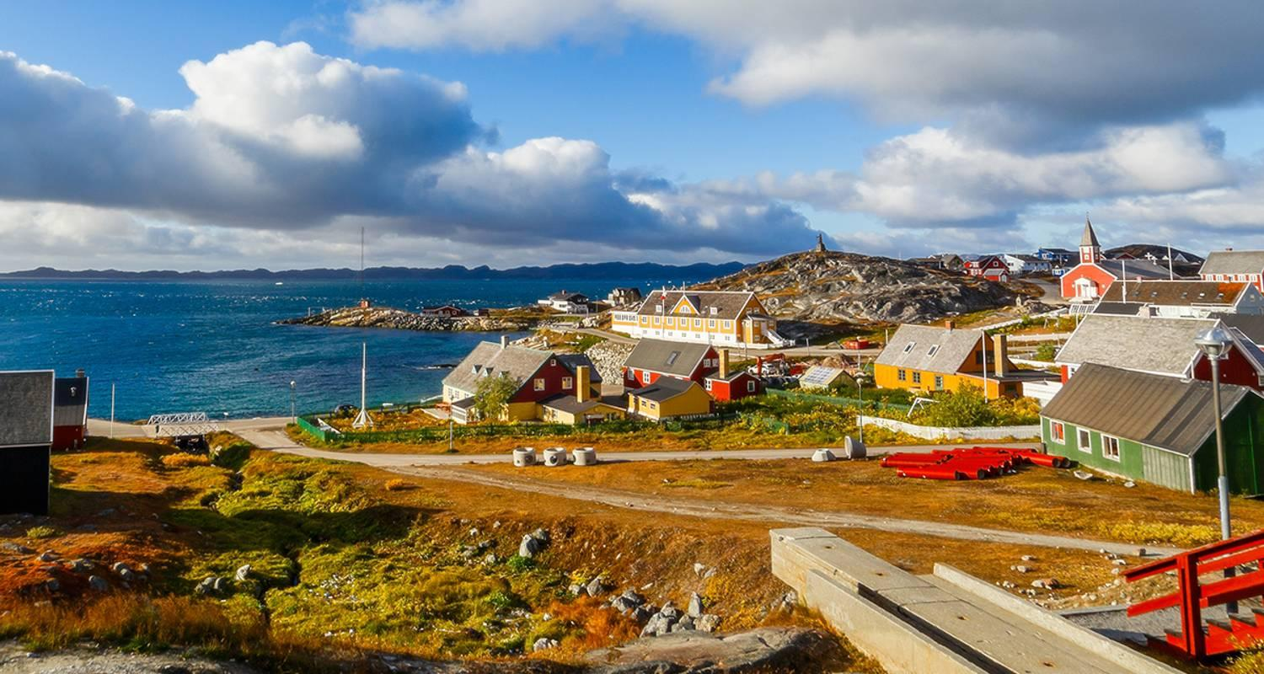

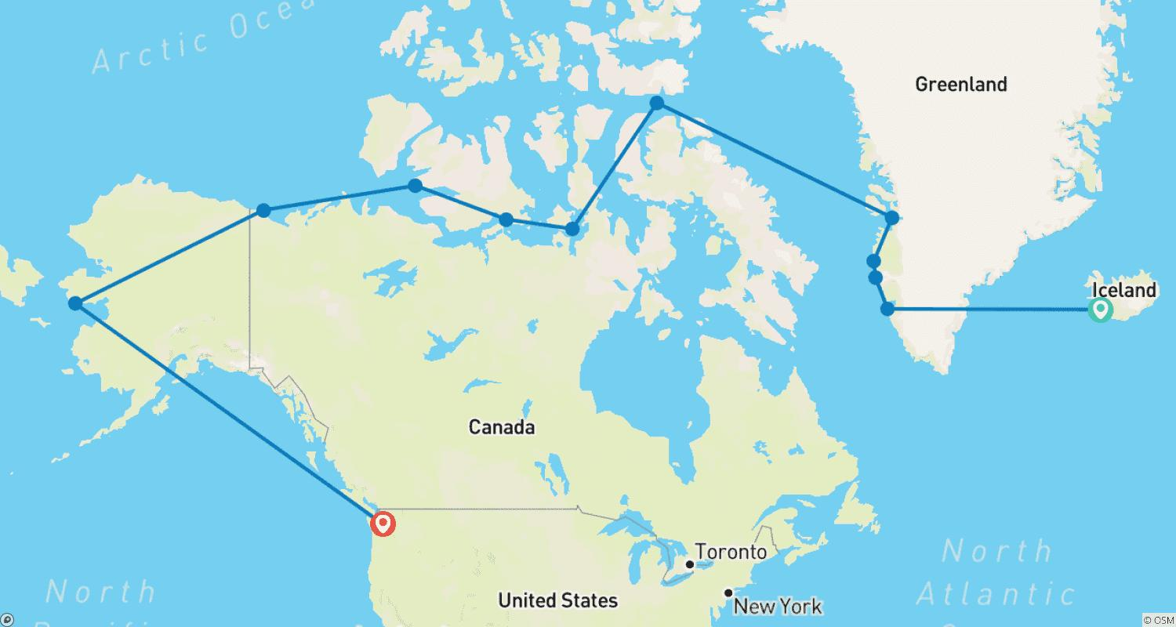

Tour ID: 262543  
Tour Name: Iconic Iceland – The Maritime Ring Route

Tour destinations: ['Reykjavik', 'Heimaey Island', 'Djupivogur', 'Husavik', 'Godafoss', 'Akureyri', 'Patreksfjordur', 'Breidafjordur']

Tour destinations images:



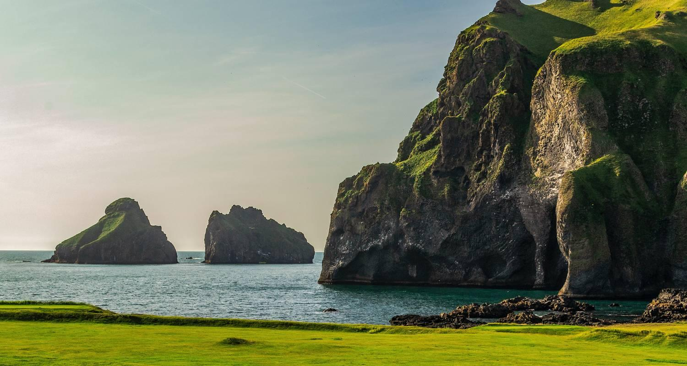

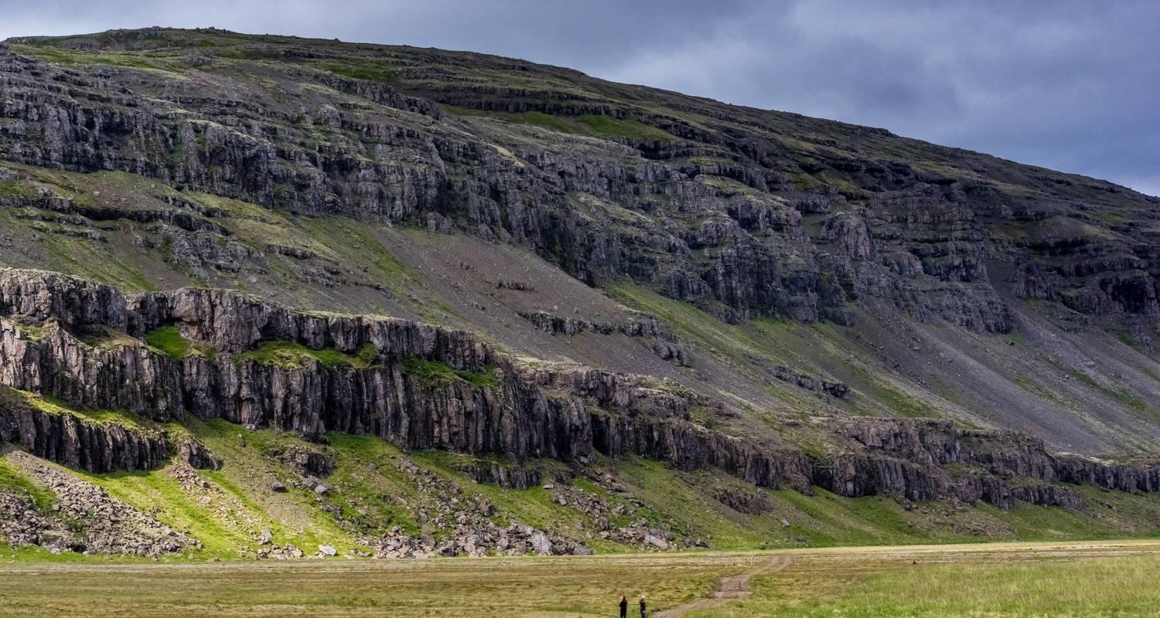

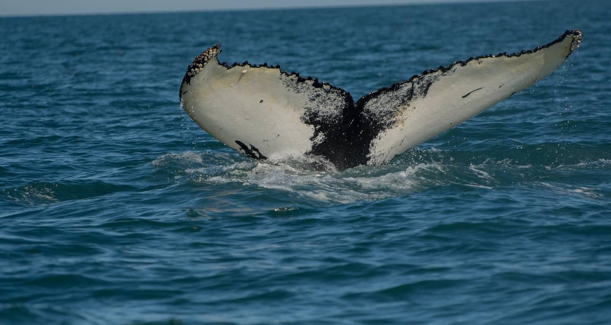

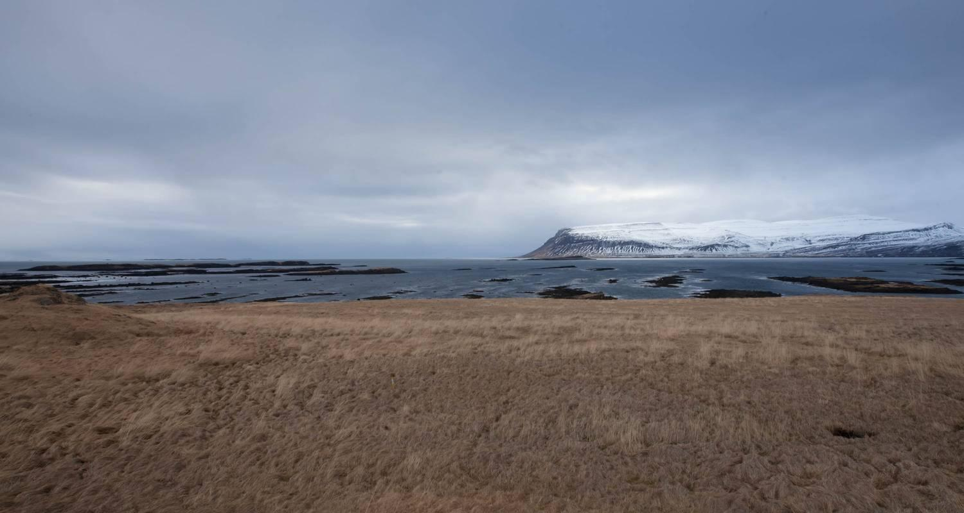

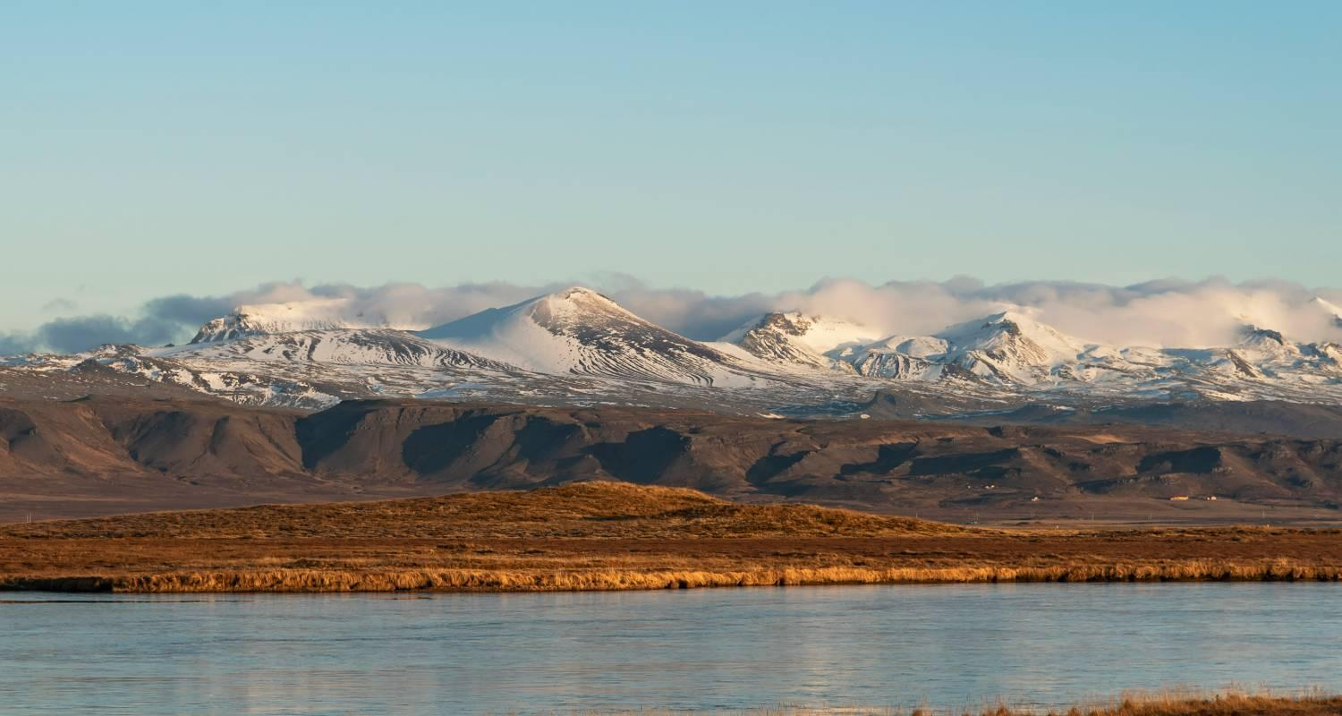

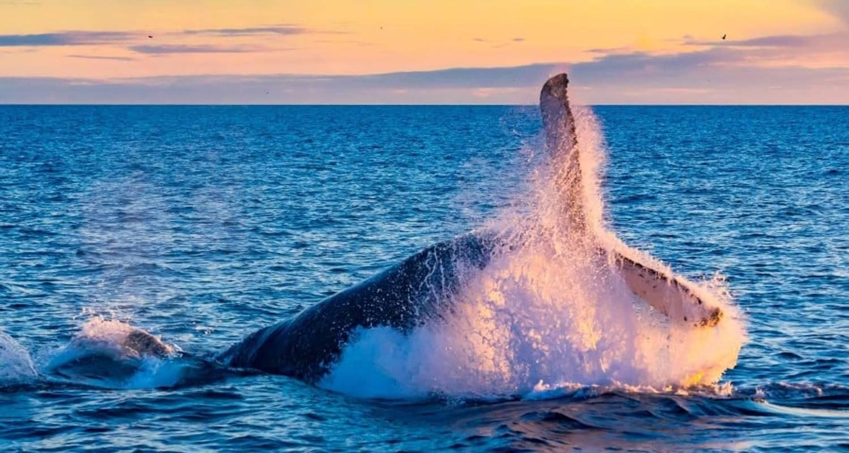

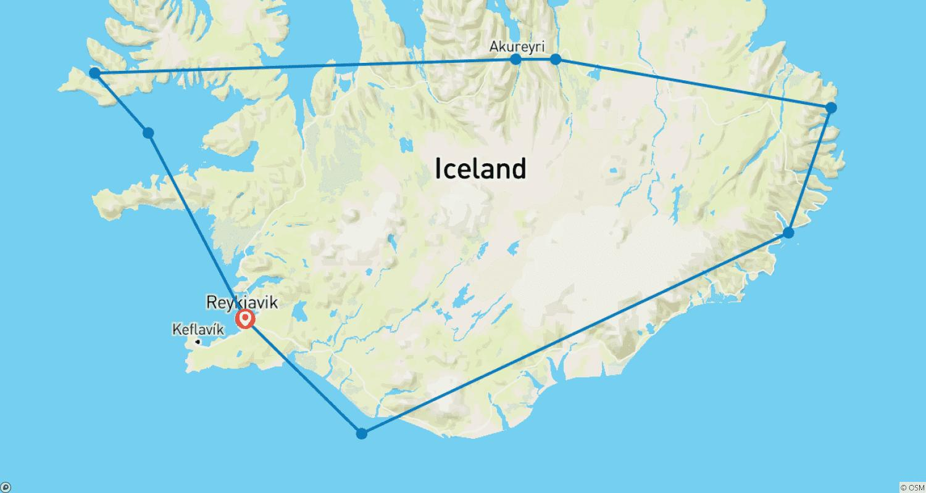

Tour ID: 262696  
Tour Name: Southwest Iceland Discovered - 7 days

Tour destinations: ['Keflavik', 'Reykjavik', 'Geysir', 'Thingvellir National Park', 'Reynisfjara', 'Skogafoss', 'Selfoss', 'Reykjanesviti']

Tour destinations images:

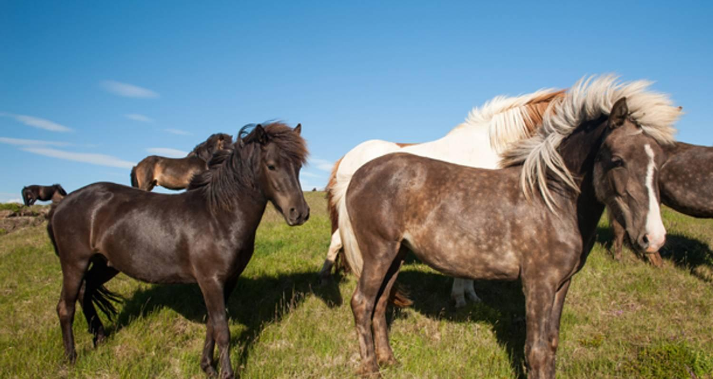

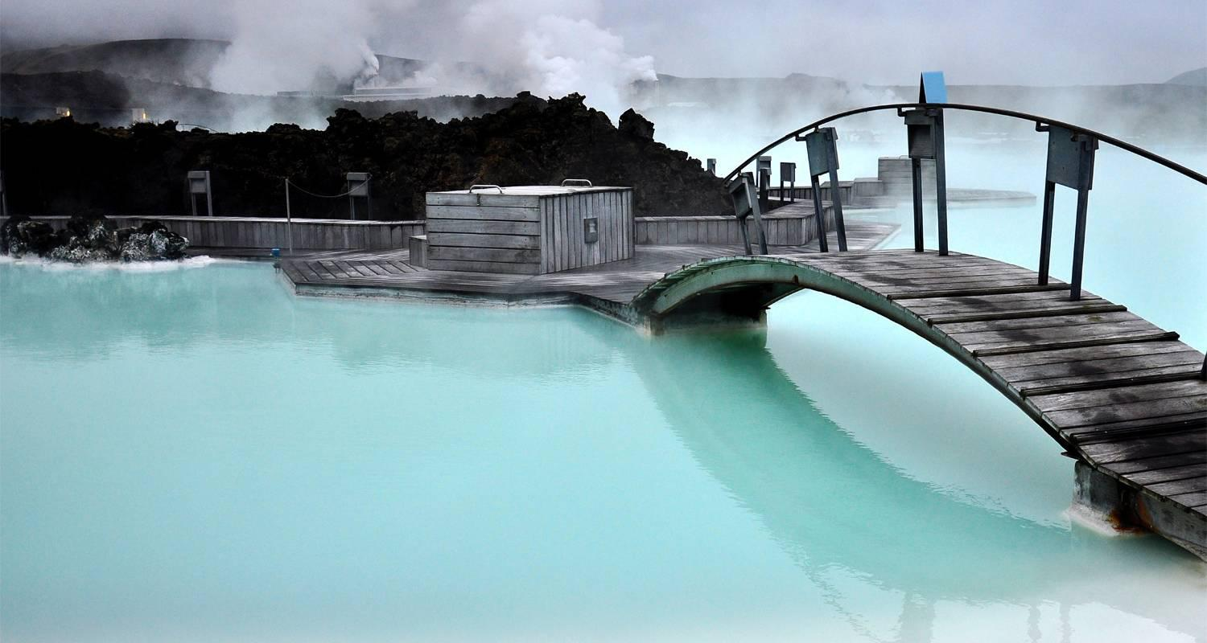

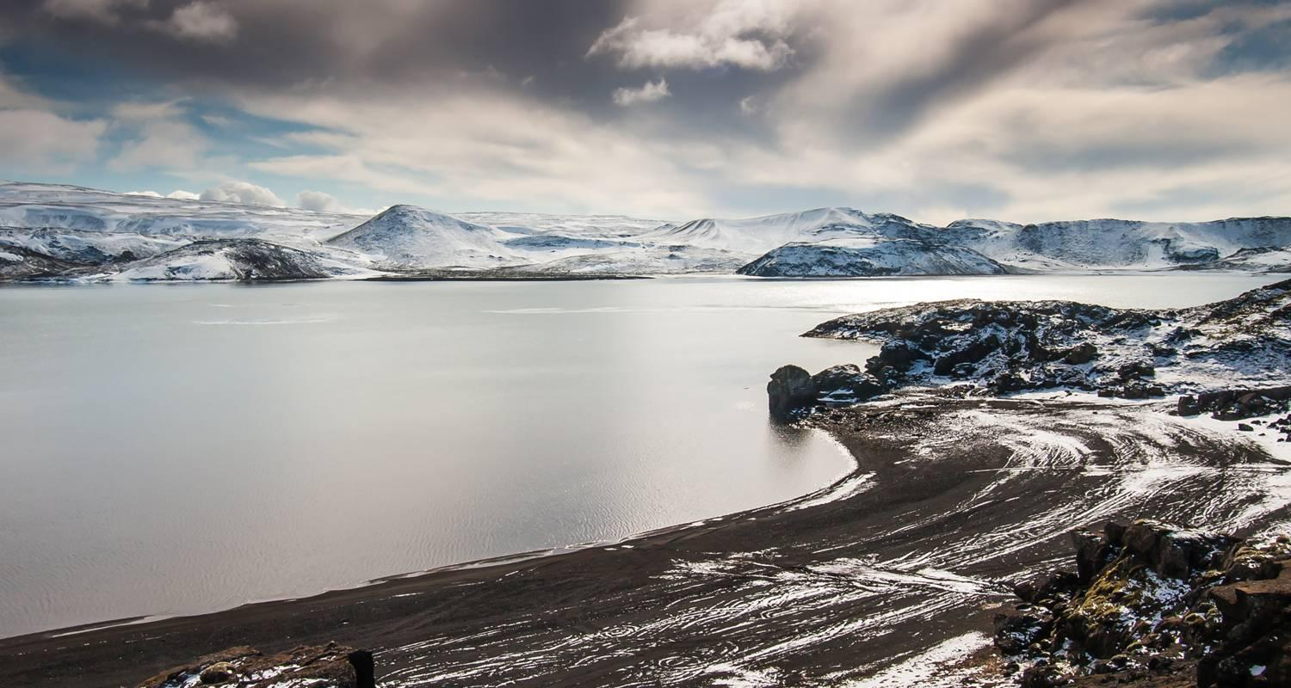

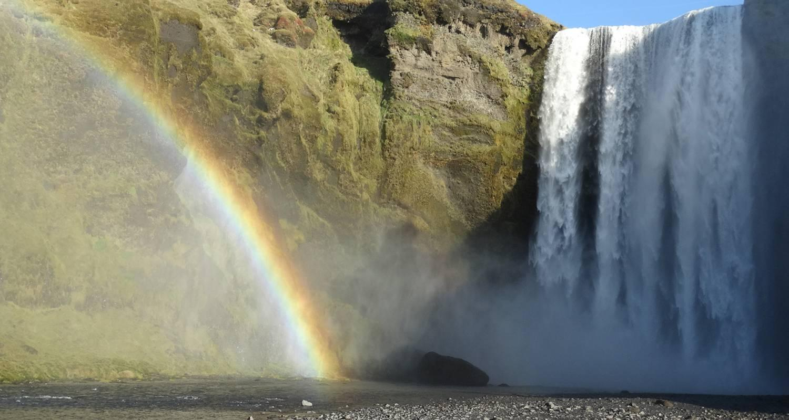

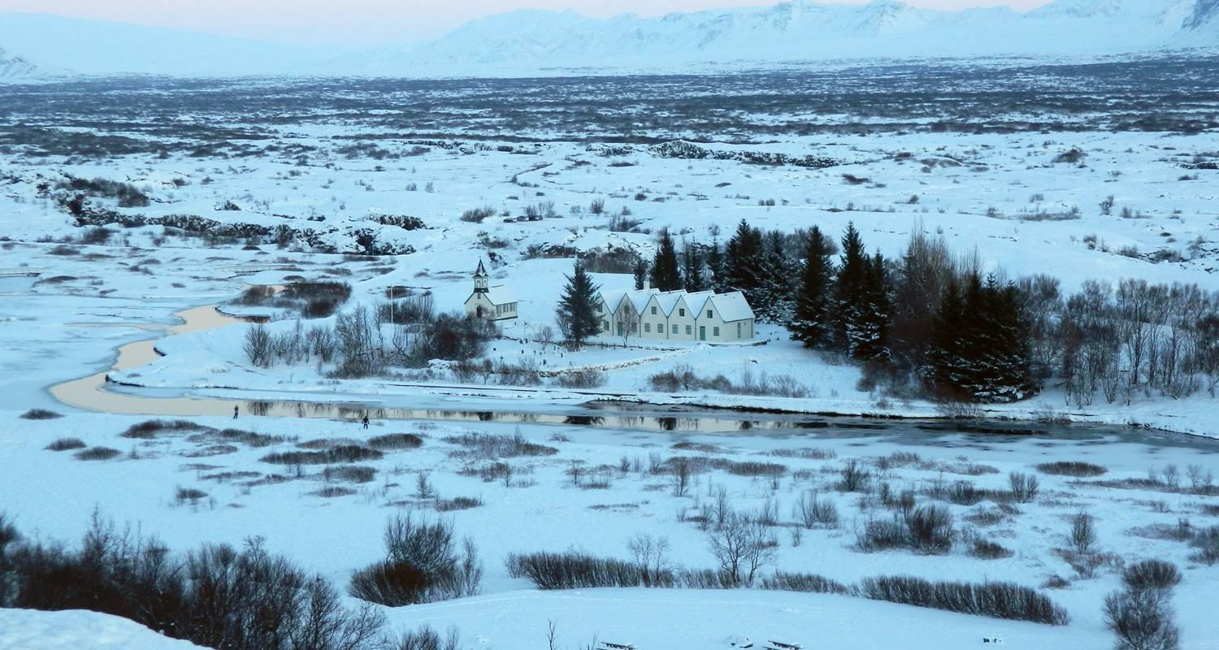

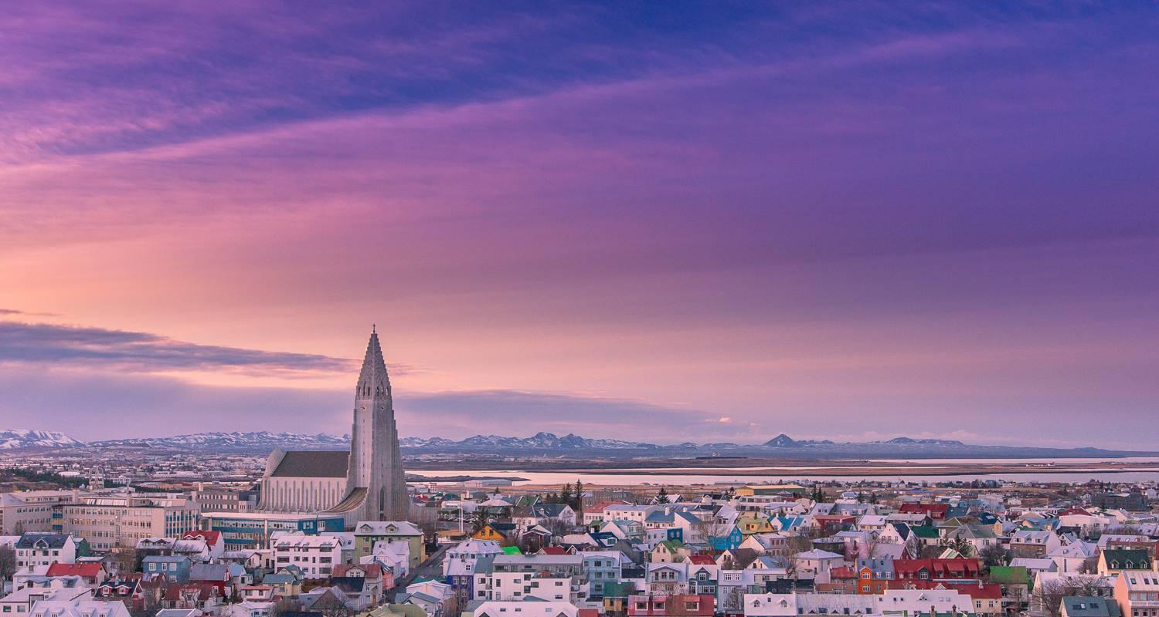

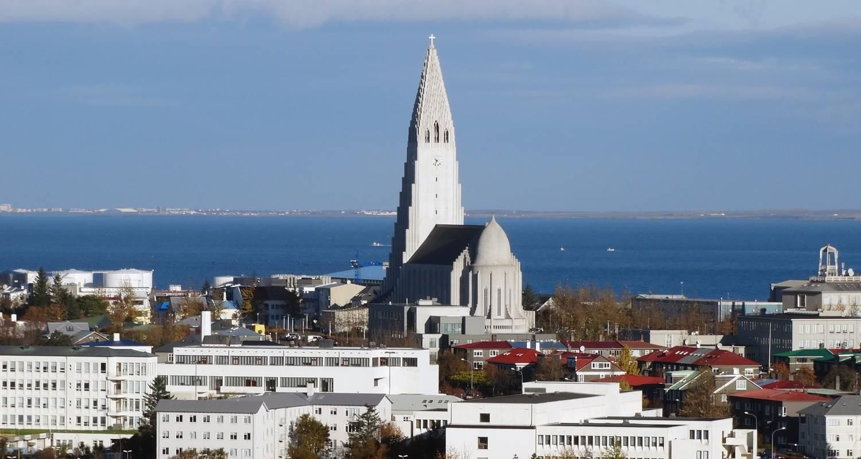

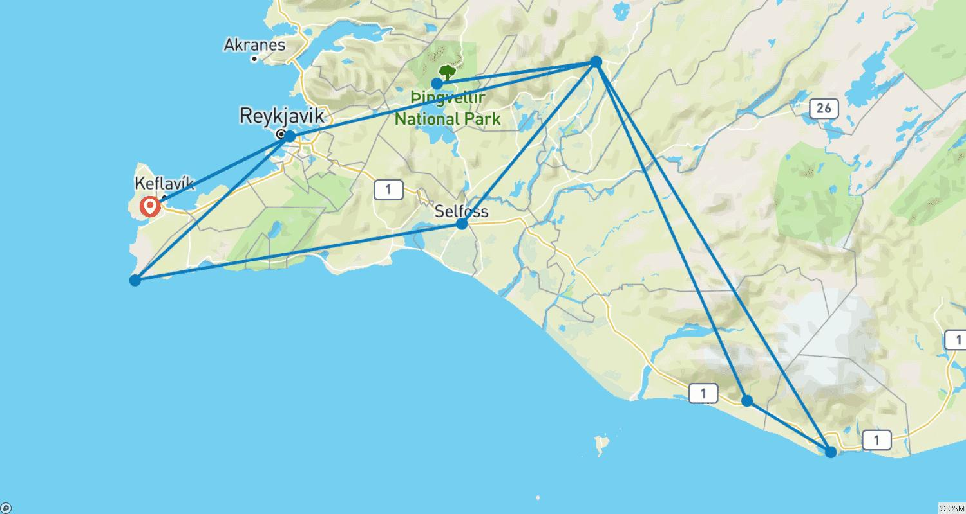

Tour ID: 262697  
Tour Name: Iceland New Years Festival - 5 days

Tour destinations: ['Reykjavik', 'Thingvellir National Park', 'Gullfoss', 'Blue Lagoon', 'Gunnuhver', 'Keflavik']

Tour destinations images:

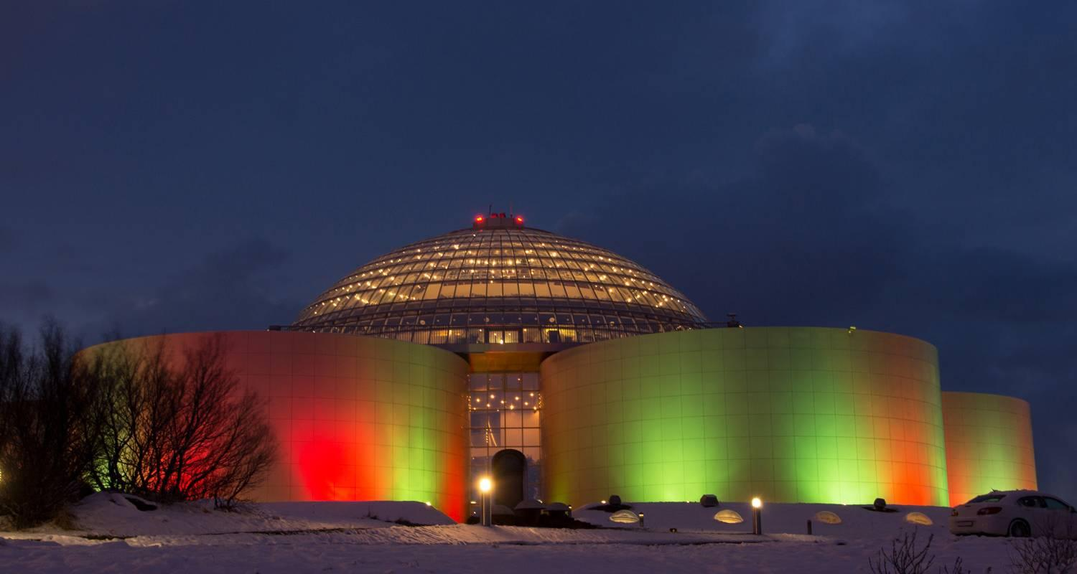



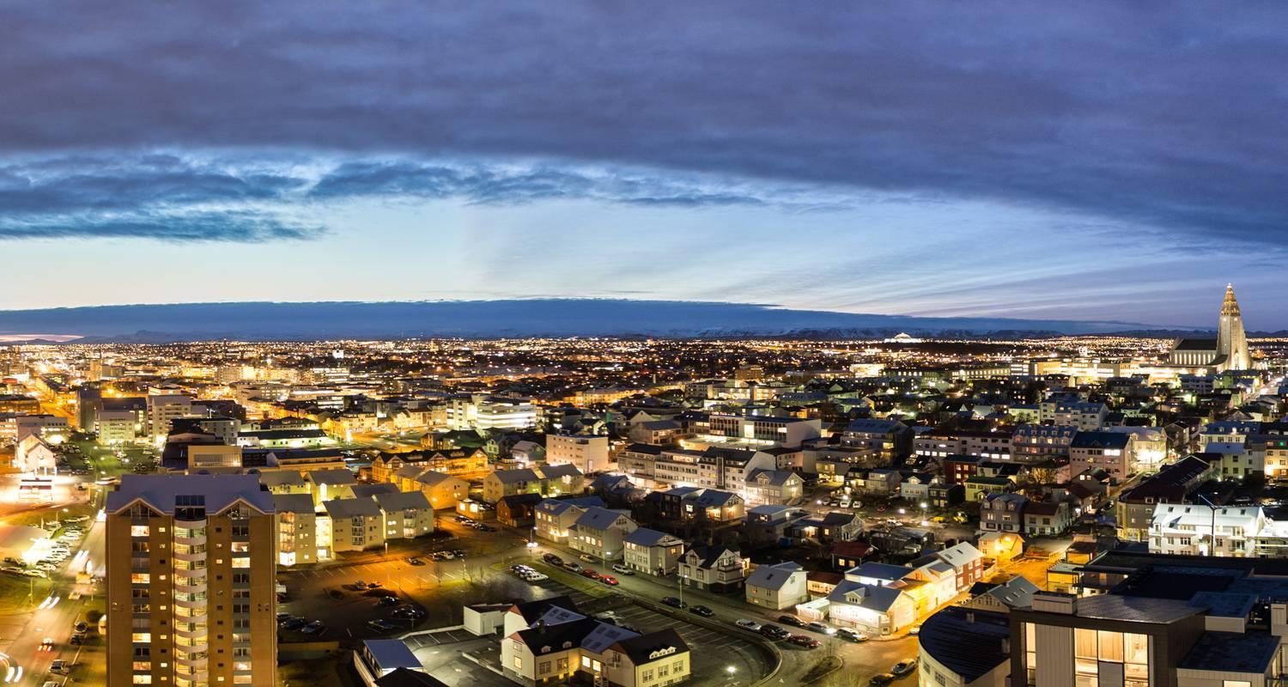



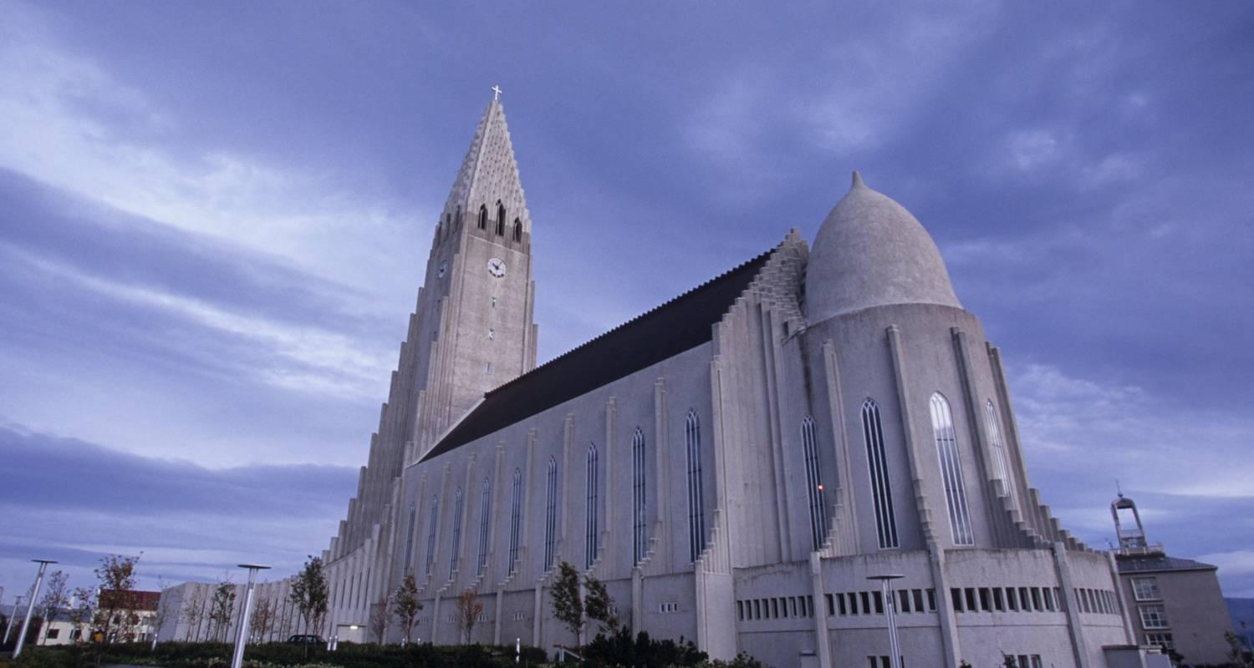

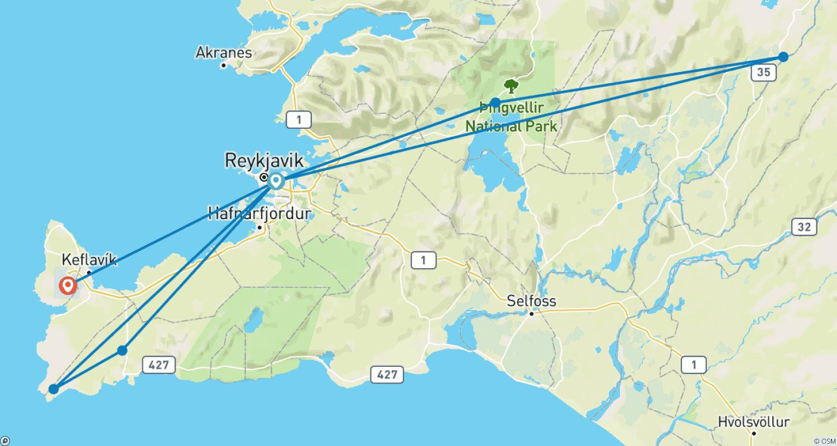

Tour ID: 262698  
Tour Name: Westfjords & Northern Lights - 7 days

Tour destinations: ['Keflavik', 'Reykjavik', 'Grábrók Volcano', 'Isafjordur', 'Dynjandi', 'Flateyri', 'Holmavik', 'Borgarnes']

Tour destinations images:



